**Apache Kafka Tutorial series**

Welcome to Spring Boot + Apache Kafka Tutorial series. In this lecture, we will take a look at Apache Kafka's important core concepts or terminologies:

- Kafka cluster

- Kafka broker

- Kafka producer

- Kafka consumer

- Kafka topic

- Kafka partitions

- Kafka offsets

- Kafka consumer group

Well, let's begin with Kafka Cluster. Well, as we know that Kafka is a distributed system, right? It acts as a cluster. Well, Kafka Cluster consists of a set of brokers. A cluster has a minimum of three brokers. Well, if you can see the diagram over here, Kafka Cluster is nothing, but it consists of a set of brokers. It means it consists of one or more brokers and it is recommended that at least you have three, you know, brokers in a Kafka Cluster in production. All right. So just remember, Kafka Cluster is nothing but it consists of one or more Kafka brokers.

Now, the question is what is Kafka Broker?. Well, a Kafka broker is a Kafka server. It's just a meaningful name given to the Kafka server and this name makes sense as well because all that Kafka does is act as a message broker between Producer and Consumer. The Producer and Consumer don't interact directly. They use the Kafka server as an agent or a broker because in the messages, for example, if you can see the diagram over here, Kafka broker, you know, it acts as the agent or a broker to exchange messages between Producer and Consumer. All right. So just remember Kafka broker is nothing but a Kafka server. It acts as a broker or an agent to exchange messages between the Producer and Consumer. All right.

Now, the question is, what is a Producer ?. Well, Producer is nothing but an application that produces the messages and sends them to the Kafka broker. Well, the Producer does not send messages directly to the recipient. It sends a message only to the Kafka server. All right. Just remember, a Producer is nothing but an application that produces the messages and sends them to the Kafka broker. Producers don't send a message directly to Consumers. It sends a message only to the Kafka Server all right now, the question is what is Consumer? Well, Consumer is basically an application that reads or consumes a message from the Kafka server. Well, If Producers are sending the data they must be sent to someone, right? The Consumers are the recipients. But remember that Producers don't send data to the recipient address, they just send it to the Kafka server first and anyone who is interested in that data can come forward and take it from the Kafka server. So any application that requests data from the server is a Consumer and they can ask for data sent by any Producer provided they have permission to read it. For example, look at here we have a Kafka broker and Producer but then nothing but an application that produces the messages and sends them to that Kafka broker and a Consumer is nothing but an application that consumes or reads a message from the Kafka server. All right.

Now the question is how the data is stored in a Kafka broker. Well, we learned that the Producer sends data to the Kafka broker. The Consumer can ask for data from the Kafka broker, but the question is what kind of data? We need to have some identification mechanism to request data from the broker where comes the topic.

Well, what is the topic? Well, the topic is basically nothing but a category in a Kafka broker where the message is basically stored. For example, let's a Producer is an application that produces the message or any data and that data will be sent to the Kafka broker. And the data can be in any format like data can be text, data can be string, data can be avro, data can be a JSON, byte array All right. But when a Consumer consumes that data, there should be an identification mechanism in order to identify which kind of data. All right. So in order to store, we know the data format we can use the topic. So the topic is nothing but a category in a Kafka broker It, you know, categorizes basically the messages or the data. Well, if we can compare a topic with a database term, the topic is like a table in a database. Well, in the database table we store the records in a sequential manner right similarly in the topic, we store the message in a sequential manner. All right. Well, the topic is identified by a name. Well, each topic contains a unique name so that Consumers can easily consume the data from that particular topic. You can have any number of topics in the Kafka cluster or Kafka broker. Well, you cannot query the message in a topic. Well, in a database table, we query the data in the table right, but in the case of a topic, you cannot query the data from that topic. The Producer has to send the data to the broker and the Consumer has to consume the data from the Kafka broker. All right. Just remember Topic is nothing but a category that categorizes the message in the Kafka broker. And each topic has a unique name so that Consumers can, you know, subscribe to that particular topic and you can, you know, create any number of topics that you want in a Kafka broker.

Next, what are Kafka's partitions? Well, Kafka's topics are further divided into a number of partitions that contains a record unchangeable sequence. Well, if we can see that diagram over here, we have topic one. This topic one is divided into a number of partitions partition one, partition two, and partition three. And again, topic two is also divided into partition one, partition two, and partition three the well. The idea behind a partition is that whenever Kafka brokers will store messages for a topic, the capacity of the data can be anonymous and it may not possible to store in a single computer. Therefore it will be partitioned into multiple parts and distributed among multiple computers since Kafka is a distributed system. Well, as we know that Kafka is a distributed system so whenever we have a large amount of data, we can divide it into partitions and we can distribute it among multiple, you know, Kafka brokers, you know, in a Kafka cluster. Right? So this is what the partitions look like. So just remember partitions are nothing but a topic is again further divided into partitions so that a huge amount of data can be divided among multiple partitions.

Next, what are Kafka's partitions? Well, Kafka's topics are further divided into a number of partitions that contains a record unchangeable sequence. Well, if we can see that diagram over here, we have topic one. This topic one is divided into a number of partitions partition one, partition two, and partition three. And again, topic two is also divided into partition one, partition two, and partition three the well. The idea behind a partition is that whenever Kafka brokers will store messages for a topic, the capacity of the data can be anonymous and it may not possible to store in a single computer. Therefore it will be partitioned into multiple parts and distributed among multiple computers since Kafka is a distributed system. Well, as we know that Kafka is a distributed system so whenever we have a large amount of data, we can divide it into partitions and we can distribute it among multiple, you know, Kafka brokers, you know, in a Kafka cluster. Right? So this is what the partitions look like. So just remember partitions are nothing but a topic is again further divided into partitions so that a huge amount of data can be divided among multiple partitions.

Now the question is how the messages will be stored in a partition of the particular topic and how the message will be identified by IDs. Well, that is where basically Offsets comes into the picture. Offset is nothing but a sequence of ids given to the messages as they arrived at the partition. Once Offset is assigned It will never be changed. The first message gets an Offset zero. The next message receives an Offset one and so on and so forth. Well, consider we have a Kafka broker and it has a topic, and the topic is divided into multiple partitions whenever you know Kafka broker stores the message in a partition of the topic, then a sequence ID will be assigned to that message and that is called Offset. Okay. For example, you can see here partition zero, partition one, and partition two, and these are the sequence IDs given to the messages, okay this is called Offset and the Offset Id starts with the 0 1 , 2, 3 like this. All right, just remember, Offset is nothing but sequence ids are given to the messages in a partition of a particular topic.

Now, let's take a look into what is Consumer groups. Well, if we can see the diagram over here, we have my topic It has multiple partitions like partition zero, partition one, and partition two and there a lot of Consumers are consuming the data from my topic. And As we can see here the Consumers are again grouped here, Consumer group A contains these four groups, Consumer B contains these two groups. All right. So a Consumer group contains one or more groups working together to process the messages. Well, just remember, the Consumer group contains one or more Consumers working together to process the messages. All right.

**So Kafka cluster basically consists of one or more brokers and the broker is nothing but a Kafka server and it basically acts as an agent or broker to exchange a message between the Producer and Consumer. The producer is nothing but an application that produces the message and sends it to Kafka Broker and Consumer is nothing but an application that reads or consumes a message from the Kafka server. A Kafka topic is nothing but a category, It categorizes the messages in a Kafka broker and we can create any number of topics in a Kafka broker and each topic, a however unique name so that Consumers can subscribe to that particular topic. Kafka topics are divided into a number of partitions that contain records in an unchangeable sequence. Offset is nothing but a sequence of ids given to messages in a partition of a particular topic. A consumer group contains one or more Consumers working together to process the messages so these are the important Apache Kafka terminologies**

Download and install [Apache Kafka](https://kafka.apache.org/quickstart)

============================================

[Apache Kafka](https://kafka.apache.org/quickstart)

[**STEP 1: GET KAFKA**](https://kafka.apache.org/quickstart#quickstart_download)

[Download](https://www.apache.org/dyn/closer.cgi?path=/kafka/3.4.0/kafka_2.13-3.4.0.tgz) the latest Kafka release and extract it:

$ tar -xzf kafka\_2.13-3.4.0.tgz

$ cd kafka\_2.13-3.4.0

[**STEP 2: START THE KAFKA ENVIRONMENT**](https://kafka.apache.org/quickstart#quickstart_startserver)

*NOTE: Your local environment must have Java 8+ installed.*

Apache Kafka can be started using ZooKeeper or KRaft. To get started with either configuration follow one the sections below but not both.

**Kafka with ZooKeeper**

Run the following commands in order to start all services in the correct order:

# Start the ZooKeeper service

$ bin/zookeeper-server-start.sh config/zookeeper.properties

Open another terminal session and run:

# Start the Kafka broker service

$ bin/kafka-server-start.sh config/server.properties

Once all services have successfully launched, you will have a basic Kafka environment running and ready to use.

**Kafka with KRaft**

Generate a Cluster UUID

$ KAFKA\_CLUSTER\_ID="$(bin/kafka-storage.sh random-uuid)"

Format Log Directories

$ bin/kafka-storage.sh format -t $KAFKA\_CLUSTER\_ID -c config/kraft/server.properties

Start the Kafka Server

$ bin/kafka-server-start.sh config/kraft/server.properties

Once the Kafka server has successfully launched, you will have a basic Kafka environment running and ready to use.

[**STEP 3: CREATE A TOPIC TO STORE YOUR EVENTS**](https://kafka.apache.org/quickstart#quickstart_createtopic)

Kafka is a distributed *event streaming platform* that lets you read, write, store, and process [*events*](https://kafka.apache.org/documentation/#messages) (also called *records* or *messages* in the documentation) across many machines.

Example events are payment transactions, geolocation updates from mobile phones, shipping orders, sensor measurements from IoT devices or medical equipment, and much more. These events are organized and stored in [*topics*](https://kafka.apache.org/documentation/#intro_concepts_and_terms). Very simplified, a topic is similar to a folder in a filesystem, and the events are the files in that folder.

So before you can write your first events, you must create a topic. Open another terminal session and run:

$ bin/kafka-topics.sh --create --topic quickstart-events --bootstrap-server localhost:9092

All of Kafka's command line tools have additional options: run the kafka-topics.sh command without any arguments to display usage information. For example, it can also show you [details such as the partition count](https://kafka.apache.org/documentation/#intro_concepts_and_terms) of the new topic:

$ bin/kafka-topics.sh --describe --topic quickstart-events --bootstrap-server localhost:9092

Topic: quickstart-events TopicId: NPmZHyhbR9y00wMglMH2sg PartitionCount: 1 ReplicationFactor: 1 Configs:

Topic: quickstart-events Partition: 0 Leader: 0 Replicas: 0 Isr: 0

[**STEP 4: WRITE SOME EVENTS INTO THE TOPIC**](https://kafka.apache.org/quickstart#quickstart_send)

A Kafka client communicates with the Kafka brokers via the network for writing (or reading) events. Once received, the brokers will store the events in a durable and fault-tolerant manner for as long as you need—even forever.

Run the console producer client to write a few events into your topic. By default, each line you enter will result in a separate event being written to the topic.

$ bin/kafka-console-producer.sh --topic quickstart-events --bootstrap-server localhost:9092

This is my first event

This is my second event

You can stop the producer client with Ctrl-C at any time.

[**STEP 5: READ THE EVENTS**](https://kafka.apache.org/quickstart#quickstart_consume)

Open another terminal session and run the console consumer client to read the events you just created:

$ bin/kafka-console-consumer.sh --topic quickstart-events --from-beginning --bootstrap-server localhost:9092

This is my first event

This is my second event

You can stop the consumer client with Ctrl-C at any time.

Feel free to experiment: for example, switch back to your producer terminal (previous step) to write additional events, and see how the events immediately show up in your consumer terminal.

Because events are durably stored in Kafka, they can be read as many times and by as many consumers as you want. You can easily verify this by opening yet another terminal session and re-running the previous command again.

[**STEP 6: IMPORT/EXPORT YOUR DATA AS STREAMS OF EVENTS WITH KAFKA CONNECT**](https://kafka.apache.org/quickstart#quickstart_kafkaconnect)

You probably have lots of data in existing systems like relational databases or traditional messaging systems, along with many applications that already use these systems. [Kafka Connect](https://kafka.apache.org/documentation/#connect) allows you to continuously ingest data from external systems into Kafka, and vice versa. It is an extensible tool that runs *connectors*, which implement the custom logic for interacting with an external system. It is thus very easy to integrate existing systems with Kafka. To make this process even easier, there are hundreds of such connectors readily available.

In this quickstart we'll see how to run Kafka Connect with simple connectors that import data from a file to a Kafka topic and export data from a Kafka topic to a file.

First, make sure to add connect-file-3.4.0.jar to the plugin.path property in the Connect worker's configuration. For the purpose of this quickstart we'll use a relative path and consider the connectors' package as an uber jar, which works when the quickstart commands are run from the installation directory. However, it's worth noting that for production deployments using absolute paths is always preferable. See [plugin.path](https://kafka.apache.org/documentation/" \l "connectconfigs_plugin.path) for a detailed description of how to set this config.

Edit the config/connect-standalone.properties file, add or change the plugin.path configuration property match the following, and save the file:

> echo "plugin.path=libs/connect-file-3.4.0.jar"

Then, start by creating some seed data to test with:

> echo -e "foo\nbar" > test.txt

Or on Windows:

> echo foo> test.txt

> echo bar>> test.txt

Next, we'll start two connectors running in *standalone* mode, which means they run in a single, local, dedicated process. We provide three configuration files as parameters. The first is always the configuration for the Kafka Connect process, containing common configuration such as the Kafka brokers to connect to and the serialization format for data. The remaining configuration files each specify a connector to create. These files include a unique connector name, the connector class to instantiate, and any other configuration required by the connector.

> bin/connect-standalone.sh config/connect-standalone.properties config/connect-file-source.properties config/connect-file-sink.properties

These sample configuration files, included with Kafka, use the default local cluster configuration you started earlier and create two connectors: the first is a source connector that reads lines from an input file and produces each to a Kafka topic and the second is a sink connector that reads messages from a Kafka topic and produces each as a line in an output file.

During startup you'll see a number of log messages, including some indicating that the connectors are being instantiated. Once the Kafka Connect process has started, the source connector should start reading lines from test.txt and producing them to the topic connect-test, and the sink connector should start reading messages from the topic connect-test and write them to the file test.sink.txt. We can verify the data has been delivered through the entire pipeline by examining the contents of the output file:

> more test.sink.txt

foo

bar

Note that the data is being stored in the Kafka topic connect-test, so we can also run a console consumer to see the data in the topic (or use custom consumer code to process it):

> bin/kafka-console-consumer.sh --bootstrap-server localhost:9092 --topic connect-test --from-beginning

{"schema":{"type":"string","optional":false},"payload":"foo"}

{"schema":{"type":"string","optional":false},"payload":"bar"}

...

The connectors continue to process data, so we can add data to the file and see it move through the pipeline:

> echo Another line>> test.txt

You should see the line appear in the console consumer output and in the sink file.

[**STEP 7: PROCESS YOUR EVENTS WITH KAFKA STREAMS**](https://kafka.apache.org/quickstart#quickstart_kafkastreams)

Once your data is stored in Kafka as events, you can process the data with the [Kafka Streams](https://kafka.apache.org/documentation/streams) client library for Java/Scala. It allows you to implement mission-critical real-time applications and microservices, where the input and/or output data is stored in Kafka topics. Kafka Streams combines the simplicity of writing and deploying standard Java and Scala applications on the client side with the benefits of Kafka's server-side cluster technology to make these applications highly scalable, elastic, fault-tolerant, and distributed. The library supports exactly-once processing, stateful operations and aggregations, windowing, joins, processing based on event-time, and much more.

To give you a first taste, here's how one would implement the popular WordCount algorithm:

KStream<String, String> textLines = builder.stream("quickstart-events");

KTable<String, Long> wordCounts = textLines

.flatMapValues(line -> Arrays.asList(line.toLowerCase().split(" ")))

.groupBy((keyIgnored, word) -> word)

.count();

wordCounts.toStream().to("output-topic", Produced.with(Serdes.String(), Serdes.Long()));

The [Kafka Streams demo](https://kafka.apache.org/documentation/streams/quickstart) and the [app development tutorial](https://kafka.apache.org/34/documentation/streams/tutorial) demonstrate how to code and run such a streaming application from start to finish.

[**STEP 8: TERMINATE THE KAFKA ENVIRONMENT**](https://kafka.apache.org/quickstart#quickstart_kafkaterminate)

Now that you reached the end of the quickstart, feel free to tear down the Kafka environment—or continue playing around.

1. Stop the producer and consumer clients with Ctrl-C, if you haven't done so already.
2. Stop the Kafka broker with Ctrl-C.
3. Lastly, if the Kafka with ZooKeeper section was followed, stop the ZooKeeper server with Ctrl-C.

If you also want to delete any data of your local Kafka environment including any events you have created along the way, run the command:

$ rm -rf /tmp/kafka-logs /tmp/zookeeper /tmp/kraft-combined-logs

[**CONGRATULATIONS!**](https://kafka.apache.org/quickstart#quickstart_kafkacongrats)

You have successfully finished the Apache Kafka quickstart.

To learn more, we suggest the following next steps:

* Read through the brief [Introduction](https://kafka.apache.org/intro) to learn how Kafka works at a high level, its main concepts, and how it compares to other technologies. To understand Kafka in more detail, head over to the [Documentation](https://kafka.apache.org/documentation/).
* Browse through the [Use Cases](https://kafka.apache.org/powered-by) to learn how other users in our world-wide community are getting value out of Kafka.
* Join a [local Kafka meetup group](https://kafka.apache.org/events) and [watch talks from Kafka Summit](https://kafka-summit.org/past-events/), the main conference of the Kafka community.

**configure the Producer and Consumer in our Spring Boot application.**

Spring Boot simplifies a lot to configure Kafka Producer and Consumer in a Spring Boot application. Well, basically Spring Boot provides auto-configuration to configure Kafka Producer and Consumer in our Spring Boot application. it means we don't have to write a Java configuration code to configure Kafka Producer in Consumer. Well, let's head over to the Spring Boot Kafka official Documentation, and let's explore how Spring Boot will simplify configuring Kafka Producer and consumer. Well, let me just type spring Kafka documentation like this hit enter, and just go ahead and click on the first link that Spring for Apache Kafka. All right. And go to the introduction section over here and here you can see so this is the dependency that we have added in order to integrate Kafka in our spring boot application right So just go down and here you can see the getting started section. Well if we don't use spring boot then we need to write a lot of configuration code. For instance, just go down and here you can see without Spring Boot we have to configure a lot of things like we have to configure the Kafka template, we have to configure a Producer factory okay, so here we can see we need to configure the Consumer factory, we need setup Consumer properties. All right. So without Spring Boot basically we need to write all this kind of, you know, boilerplate Java configuration code, but Spring Boot simplifies all these things. Okay, so Spring Boot offers external properties that we can simply use in our application.properties file to configure Kafka for design consumer. Well, just remember without springboard we need to write a lot of configuration code to configure Kafka to configure Kafka Consumer and Producer For example, we need to configure Consumer factory bean, we need to configure in Kafka template. We need to configure or factory. All right. We need to create a lot of configuration code in order to configure Kafka Producer and Consumer if we don't use Spring boot Okay. But Spring Boot simplifies all this configuration. Spring boot by default configure all these beans for us we don't have to write all this much of code in order to configure Kafka Producer and Consumer in our our spring boot application. Okay, I hope you understood. Well, let's go back to IntelliJ IDEA and let's configure a Kafka Producer and Consumer. Well, let me go the IntelliJ idea here and let's go-to resources section and open the application.properties file. Within application.properties file, we are going to configure the Kafka broker server address as well as Consumer and producer a related configuration. Well, let's take the property spring.kafka.consumer So first will configure Consumer and then we'll configure are spring.kafka.consumer .bootstrap-servers So this property basically we use to configure all the Apache Kafka, you know, servers. Right now we have only one Apache Kafka broker which is running locally, right? So let's write the value as localhost:9092. Well, right now we have only one Kafka broker's service which is running on the local machine. But let's say if we have multiple Kafka broker services running on your cluster, then what you need to do is you need to mention all those Kafka brokers, you know, separated by a comma. For example localhost:9092, localhost:9091. Let's say if another Kafka broker is running on 9093 and you need to mention all these Kafka server addresses separated by comma here. All right now we have only one Kafka broker service which is running on port 9092. Next, we need to configure the Consumer group just type the property spring.kafka.consumer. group-id So basically we need to provide a Consumer group to which the Consumer is belongs to. For example, let's say myGroup. Well if you can head over to Kafka ecosystem diagram over here. Well, here we have a Consumer group. It consists of multiple consumers like consumer one, consumer two, consumer three. Right. So we have mention the Consumer Group I.D. in which the Consumer belongs to. So in our case, we are going to provide the unique group I.D.. that is myGroup. All right. I hope you understood the usage of this property. Right. So we need to provide the, you know, Consumer group I.D. in which the Consumer is belongs to. Next, we need to configure Offset for this Consumer. So just type the property spring.kafka.consumer.auto-offset-reset and then let's provide a value as earliest. Well, we need to specify this property because this property specifies what to do when there is a no initial offset in a Kafka or if the current Offset does not exist anymore on the server. And here we have provided a value earliest because it will automatically reset Offset to the earliest offset. and there are a couple of values as well like the latest, none and ahything but you know, most of the time we use earliest okay, earliest. so this will automatically reset the object to the earliest object. Next, we need to configure the Consumer key and the value Deserializer. Well, just type the properties spring.kafka.consumer.key-deserializer: org apache.com.common.serialization.StringDeserializer. Well, we are using StringDeserializer class from Kafka library to Deserializer key in a message. So similarly we need to use the Deserializer class to Deserializer a value in a message. Right So let me simply copy this property and let me paste it over here and let me change from key to value. All right. So let me simply copy this property and let me paste it over here and let me change from key to value in a message. Next, we'll configure a producer. Well, we are going to again use Spring Boot provided properties in order to configure Apache Kafka Producer Well, just have the property spring.kafka.producer.bootstrap-servers: localhost:9092. So for Producer also we're using the same Apache Kafka broker service, right which running on port 9092. Next, we need to configure the serializer a class for key and value in the Producer as well. Just type the property spring.kafka .producer .key-serializer : org.apache .kafka.common.serialization.StringSerializer We are going to use StringSerializer class in order to serialize the key in a message to simply hit enter. So I am going to copy this and paste it over here. In order to configure the StringSerializer class to serialize a value in a message right And instead of just, you know, type the value here. Now we have configured serializer classes to serialize key and value in a message. This is pretty much it. So this is how basically we configure Kafka Producer and Consumer in our Spring boot application using Spring Boot provided external properties. this is awesome, right? We don't have to write a lot of configuration code in order to configure Kafka Producer and Consumer in our Spring Boot application. Spring Boot will automatically provide a lot of autoconfiguration. So we have to just use the external properties in order to configure Kafka Producer and Consumer. All right, now let's go ahead and it's run the Spring Boot application here to verify whether this configuration works properly or not. So let me run the Spring Boot application. Let me go to the main entry point class and from here I am going to run the Spring Boot application and there we go. Spring Boot application is running on embedded server on port 8080 It means this configuration that is Kafka Producer and Consumer configuration in application.properties file is working as expected. All right, great. I will see you in the next lecture.

you will learn how to create a Kafka Producer to produce a message and send it to the Kafka broker and how to create a Kafka consumer to consume the message from the Kafka broker. All right.

**Apache Kafka is nothing but an open-source distributed, even stream platform used by thousands of companies for high-performance data, pipeline streaming analytics, data integration, and mission-critical applications.**

Well, Apache Kafka was initially built by, you know, LinkedIn, but later on it wasn't managed by the Apache Foundation. Well, in order to understand more about Apache Kafka, let's take a look at how apache Kafka looks in a nutshell.

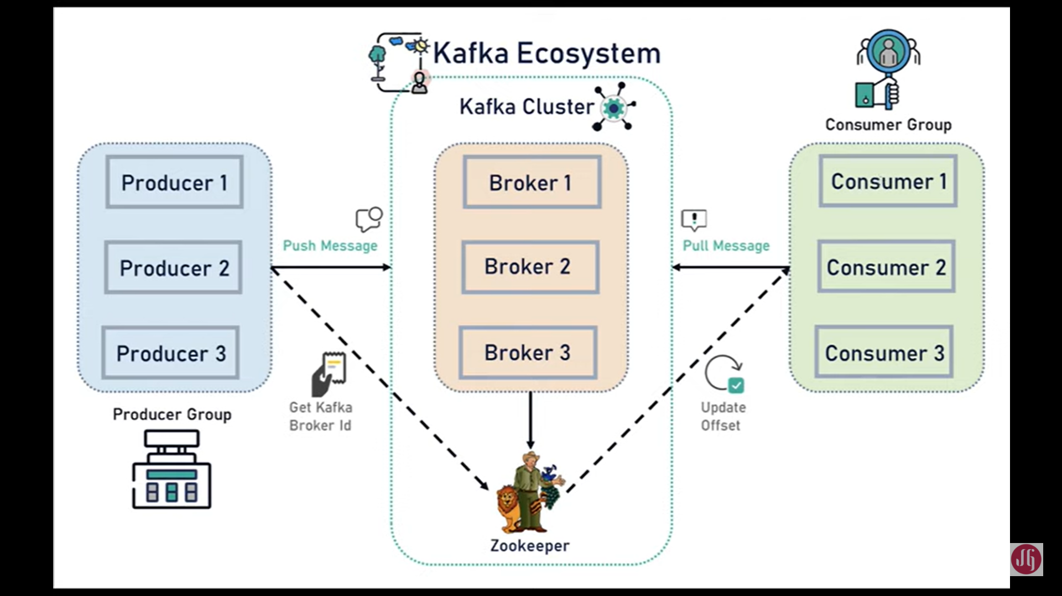

As we can see this is the Apache Kafka ecosystem. Well, as we know, that Apache Kafka distributed system so it acts as a Kafka cluster. Well, a Kafka cluster is anything but a cluster it has one or more Kafka blockers. You can see in the diagram we have broker one, broker two, and broker three. Well, whenever you use Kafka in a production, make sure that you at least use three brokers in a Kafka cluster. All right. So here you can see the producer and consumer. Well, Producer is nothing but an application that produces the messages and sends that message to the Kafka broker.

Well, the producer can produce any kind of message like a message can be an event, the message can be a stream of records, stream of data, the event can be Avro, plaintext, stream, JSON Okay. So Producer basically produces the message and sends that message to the Kafka cluster. All right. And then here you can see the consumer. Well, consumers will basically consume those messages from the Kafka broker. All right. So there is one more Kafka term that is topic. So we basically create a topic in a Kafka cluster so that a consumer can able to subscribe to that particular topic.

Well, here you can see one more important service which is Zookeeper. Well, the zookeeper plays a very important role here. So the Zookeeper basically manages the state of all these Kafka brokers Okay. So Cluster can contain a lot of Kafka brokers. Right. So there should be some way to manage the state of all these brokers in a cluster, right? so that is what the zookeeper does. So Zookeeper basically maintains the state of all the Kafka brokers in the Kafka cluster, as well as Zookeeper, maintains the configuration of all the topics, producers, and consumers. All right.

So Zookeeper basically plays a very important role in the Kafka cluster. Well, this is how the Kafka ecosystem looks at a high level. All right. So Apache Kafka is a distributed streaming platform. It means Apache Kafka can act as a cluster so that it can know contains one or more capture brokers and Apache Kafka is fault tolerance. Fault tolerance means if one node or broker goes down, then it can have the capability to manage the other nodes as well because the data is distributed among different Kafka brokers. Right. If one node or Apache Kafka goes down, then it has the capability to manage the entire cluster. Right.

Well, the data can be stored in Apache Kafka broker at any duration so that the consumers can be able to consume the history data from the Kafka broker. Okay, so these are the few important features of Apache Kafka. Well, let's take a look into some of the use cases of Apache Kafka. So here you can see these are the few popular use cases for Apache Kafka. Well, messaging.

Well, as we know that there are some traditional messaging systems like ActiveMQ or RabbitMQ so this Apache Kafka works well as a replacement for traditional message brokers. All right. And website activity, tracking metrics, log aggregation, stream processing, event sourcing, and commit logs so are the few popular use cases for Apache Kafka. Well, if you want to know more about Apache Kafka, then you can go ahead and read this introduction page. So this page will give you a brief idea about what is Apache Kafka and where you can use Apache Kafka. All right.

In the next lecture, I'm going to cover the important key technologies and the core concepts of Apache Kafka so that it will be easy for you to understand whenever we use Apache Kafka in a Spring Boot application. All right, I will see you in the next lecture.

[**❮ Previous Lecture**](https://www.javaguides.net/p/spring-boot-apache-kafka-tutorial-free.html)

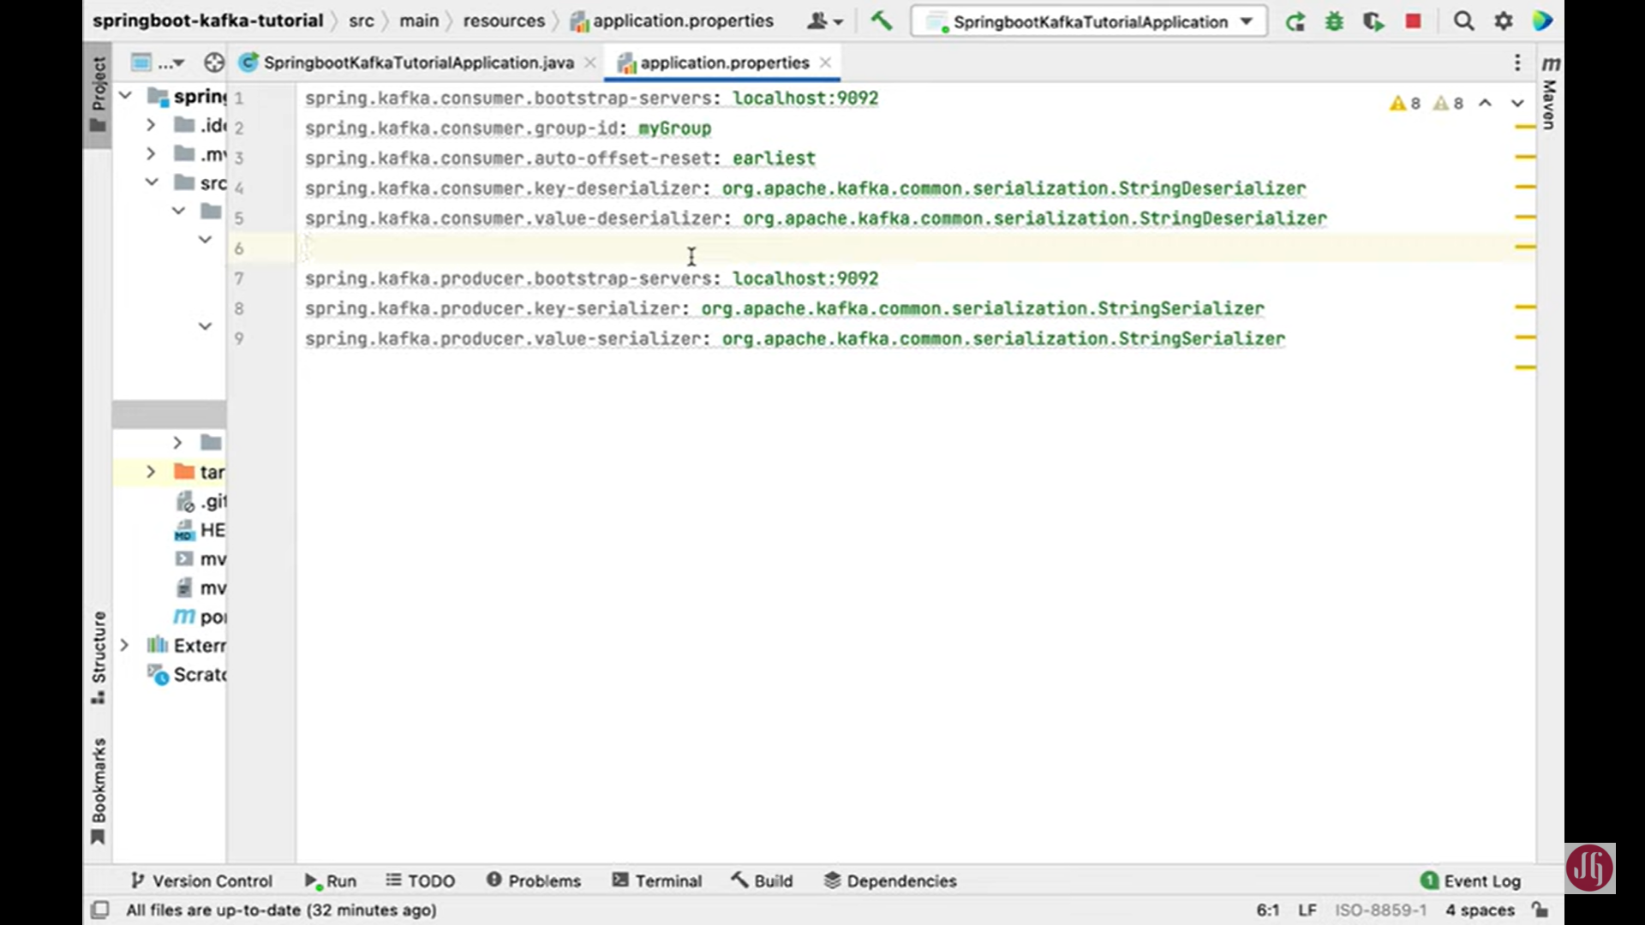

Create Topic in kafka Clustor

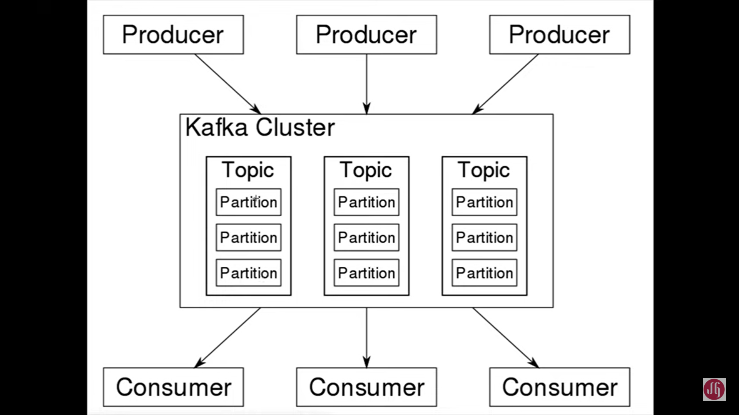

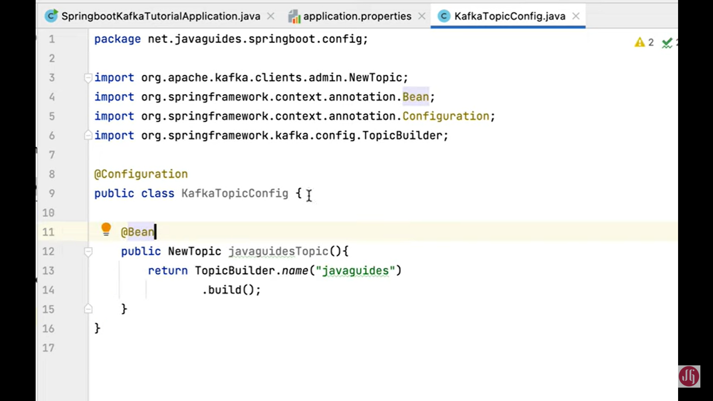

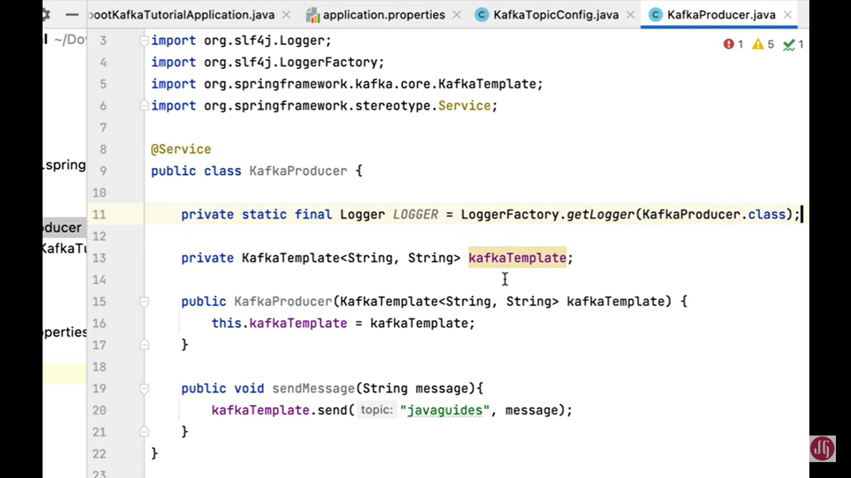

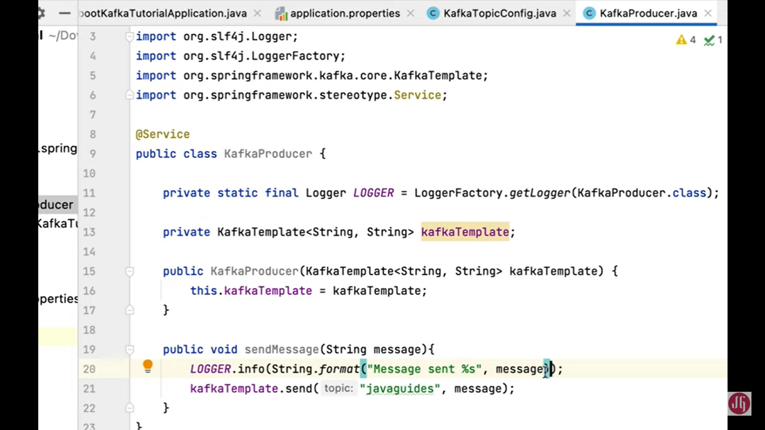

### Create REST API to Send Message

we will create a REST API to send a message to Kafka Producer. Well, if we can see the Kafka architecture over here in the previous lecture, we have created a Kafka producer. Right? In this lecture, we will create a REST API to send a message to the Kafka producer, and then Kafka Producer will send that message to the Kafka topic. Okay, let's head over to the IntelliJ idea, and let's create one simple REST API to send a message from the client. Well, let me create a new package, and let me call it a controller. Within a controller package, Let's create a class and let's name it as MessageController Hit enter and let's annotate this controller class with @RestController annotation in order to make this class as it spring MVC REST controller and let's also use @RequestMapping annotation to define the base URL for the REST API. So here I am going to use /api/v1/kafka. Well, within the MessageController, we're going to create a rest endpoint so before that, we need to inject the Kafka Producer so let's private KafkaProducer kafkaProducer so we're going to use a constructor basically dependency injection in order to inject KafkaProducer. So let me create a constructor over here. Generate constructor and okay, so here we're not going to use @Autowired annotation, okay because if Spring bean has only one constructor then we can avoid using @Autowired annotation. Okay. You can use @Autowired annotation but Spring 4.2 onwards we can ignore this annotation if the spring bean contains only one parameterized constructor. As you can see in our case this message controller spring bean has only one parameterized constructor so Spring IOC will by default inject this dependency. Okay great now let's create the REST endpoint let's say public and then let's use a response entity as a response type and let's pass string as a type and then let's say send message or let's say publish as the method name and then string message as the method parameter. Let's annotate this method with @GetMapping annotation and let's pass the URI something like /publish. And then in order to, you know, get the value from the URL, we're going to use query parameters. So let's use @RequestParam annotation in order to get the value from the query parameter and let's provide a key as a message Okay. So we're going to basically retrieve a value from the query parameter that's why we're using here @RequestParam annotation. And the key that we are going to define a query parameter is a message. Okay, something like this. So let me create REST endpoint URL for you. Let's say a http:localhost:8080/api/v1/kafka/publish and then in order to define the query parameter, we use a question mark followed by that query parameter key that is a message and then we provide a value, let's say Hello World. Okay, so this is the message that we have provided over here as a key and in spring we use @RequestParam annotation to retrieve value of this query parameter. Okay. and that value will be stored in this message. All right, great. Now let's go ahead and let's call the Kafka producer in order to pass this message. So here I am going to call KafkaProducer and then call it method, sendMessage and then pass the message to it and simply return response entity dot Ok and in response, just pass like a message sent to the topic something like this. Now we have built a simple REST API that will publish a message to KafkaProducer and Kafka Producer internally use a Kafka template to send that message to the Kafka topic. Now let's run the Spring Boot application and let's call this REST API to send a message to the topic. Well, let me run the Spring Boot application from here and you can see Spring Boot application is running on embedded tomcat server on port 8080. Now let's go to the browser and from the IntelliJ idea let me simply copy this URL and paste it into a browser and hit enter and there we go. Well, REST API has returned the response message sent to the topic. It means that the REST API that we have built to send a message to the Kafka topic is working as expected right. Now, let's go ahead and let's verify whether this hello world message is successfully sent to the Kafka topic or not. In order to do that, let's go to Kafka quick quickstart page over here and let's go to the steps. So let's go to step three. Create a topic to store your events. We have already created a topic in a Kafka cluster using Spring Boot application. Let's move to the next step. Write some events into the topic. Well, we have already created a Kafka producer and we have already created a simple API to send a, you know, message to the topic. So let let's move to the next step. Read the events or messages from the topic. Well, we use this command in order to verify whether the message is written to the Kafka topic or not. Okay. So this is basically a Kafka provided sh file It acts as basically consumer. So let me simply copy this command and let me execute it in a terminal so that we can able to see whatever the, you know, messages that we have sent to the Kafka topic. So let's go to terminal again and in a terminal open a new cell, if you are using windows, then make sure that you open a windows, you know, a command prompt. So just go to Downloads folder so we have Kafka in Downloads folder right So cd downloads, cd Kafka from here we simply paste the command. Well, within this command we need to change the topic name. Right here you can see the topic name quickstart-events but we are given a topic name as javaguides right? So let's go ahead and let's change this topic name to javaguides and hit enter and here you can see. So these are the messages that are there in a Kafka topic. Okay. And we have sent hello world message, right? So now we can able to read that Hello, world message from the Kafka topic. Well, let me send one more message. So let's say let's say test Kafka message in a topic something like this and hit enter and let's go to terminal and there we go test Kafka message in a topic. So it means that Kafka producer has sent a message to the Kafka topic and Kafka consumer consumes that message from the Kafka topic. Well, let's go ahead and let's send one more message to the topic. Let's say Kafka topic one, two, three, something like that, and go back to the terminal and if you are able to see Kafka's topic successfully read from the Kafka topic. So this kafka-console-consumer.sh file So this sh file we can use to simply read the events or messages from the Kafka topic. Okay, now we have seen how to read events or messages from the topic by using the command line. In the next lecture, we'll create a Kafka consumer to consume the message from the Consumer. All right, I will see you in the next lecture.

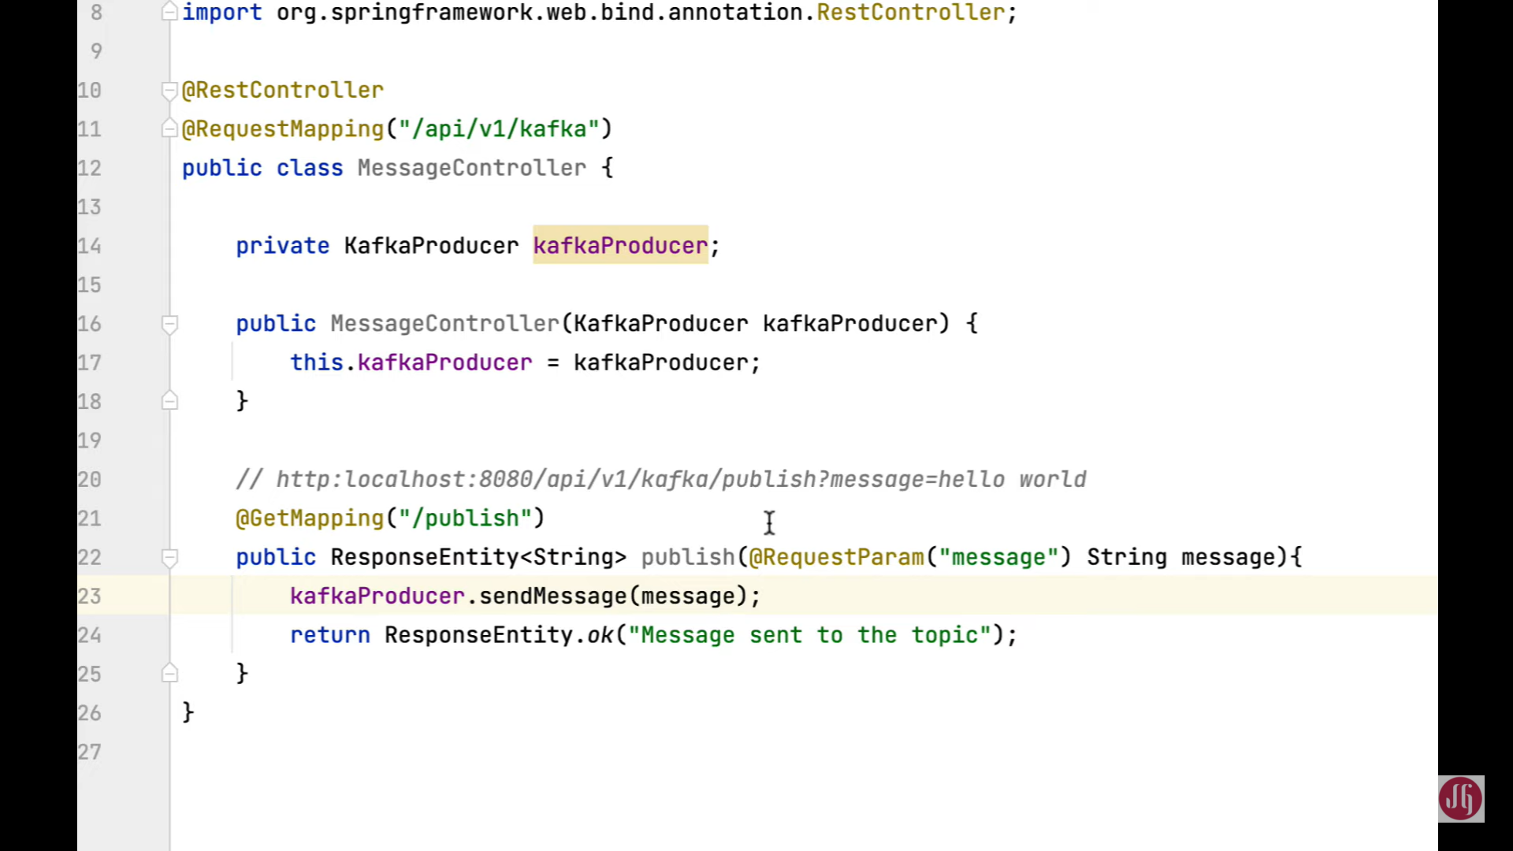

# Graphical user interface, text, application, email Description automatically generated Configure Kafka Producer and Consumer for JSON Message

we will configure Kafka Producer and Consumer for JSON Serializer and Deserializer. Well, in the next upcoming lectures, we will see how to send and receive JSON object as a JSON byte array to and from Apache Kafka. Let's head over to the IntelliJ idea and let's change the application.properties file to configure JSON Serializer and Deserializer for Kafka Producer and Consumer. Well, let me head over to the IntelliJ IDEA, let's go to application.properties file over here. So here you can see we have used StringDeserializer and StringSerializer classes to serialize and deserialize message key right so we're going to keep StringDeserializer and StringSerializer classes from Kafka library for this message key we're not going to change the StringDeserializer and StringSerializer classes for this key, we're going to only change the message value. Okay, so here you can see right now we have StringDeserializer class from Kafka Library to deserializer the value for this Consumer. So let's go ahead and let's change it. So let's use JsonDeserializer from Spring Kafka Library. So let me comment on this and here I want to type the property spring.kafka.consumer.value- deserializer and then the value is org.springframework.kafka.support.serializer.JsonDeserializer Okay. Now we are using JsonDeserializer class from spring provided library, not from the Kafka library. Okay. So this JsonDeserializer is basically created by Spring Kafka library, not from Kafka library. Okay. Now we have configured JsonDeserializer for this Kafka Consumer. So a Consumer will basically, you know, convert JSON byte into the Java object by using this JsonDeserializer Now let's go ahead and let's see how to configure JsonSerializer class for this Kafka Producer. So right now we are using StringSerializer class to serialize the value from the Kafka Library right. So let me simply comment it out this and let me write the property. spring.kafka.producer.value-serializer: then type the value org.springframework .kafka.supoort.serializer.JsonSerializer Okay. It means that this Kafka Producer will basically convert Java object into JSON and then it will write to the Kafka topic. All right. Now we have configured Kafka Consumer and Kafka Producer for JsonDeserializer and JsonSerializer All right, great. Well, in a Kafka Consumer, we can also configure one more property that is spring.kafka .consumer.properties .spring.json.trusted.packages=\* It means that Kafka Consumer can JsonDeserializer all the classes from this package. Okay, here star (\*) meaning all the classes from this package. All right, perfect. Now we have configured Kafka Consumer and Producer for JsonDeserializer and JsonSerializer. All right, in the next lecture, we'll create a simple POJO class that we can write to the Kafka topic.

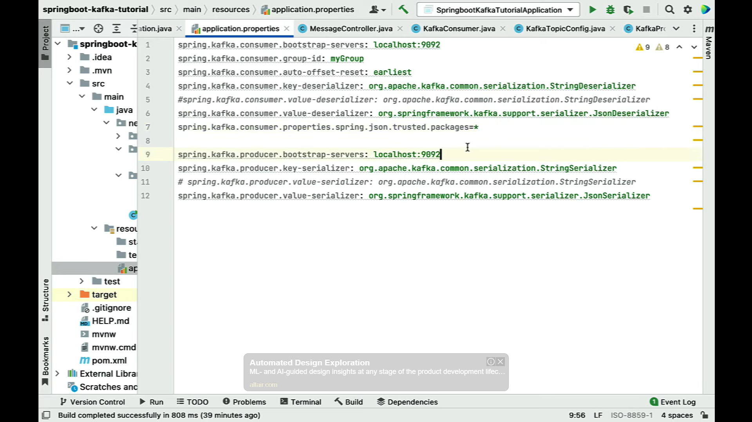

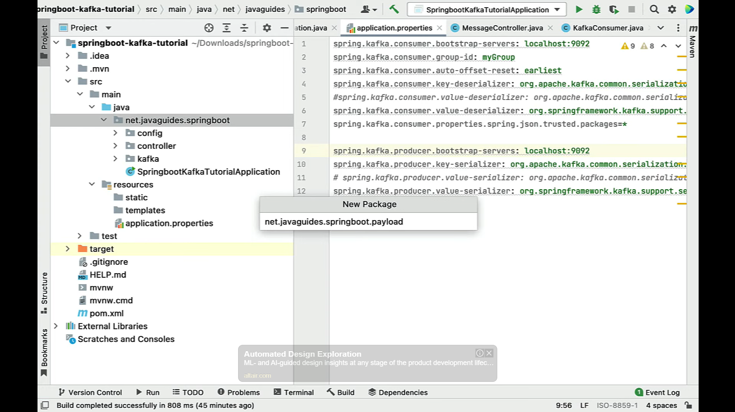

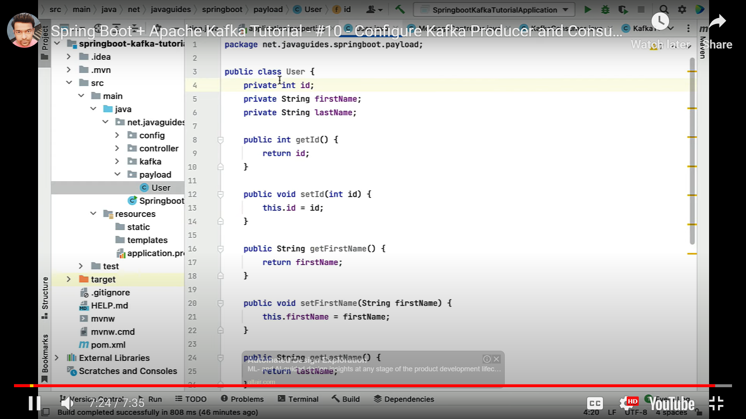

### Create Kafka Producer to Produce JSON Message

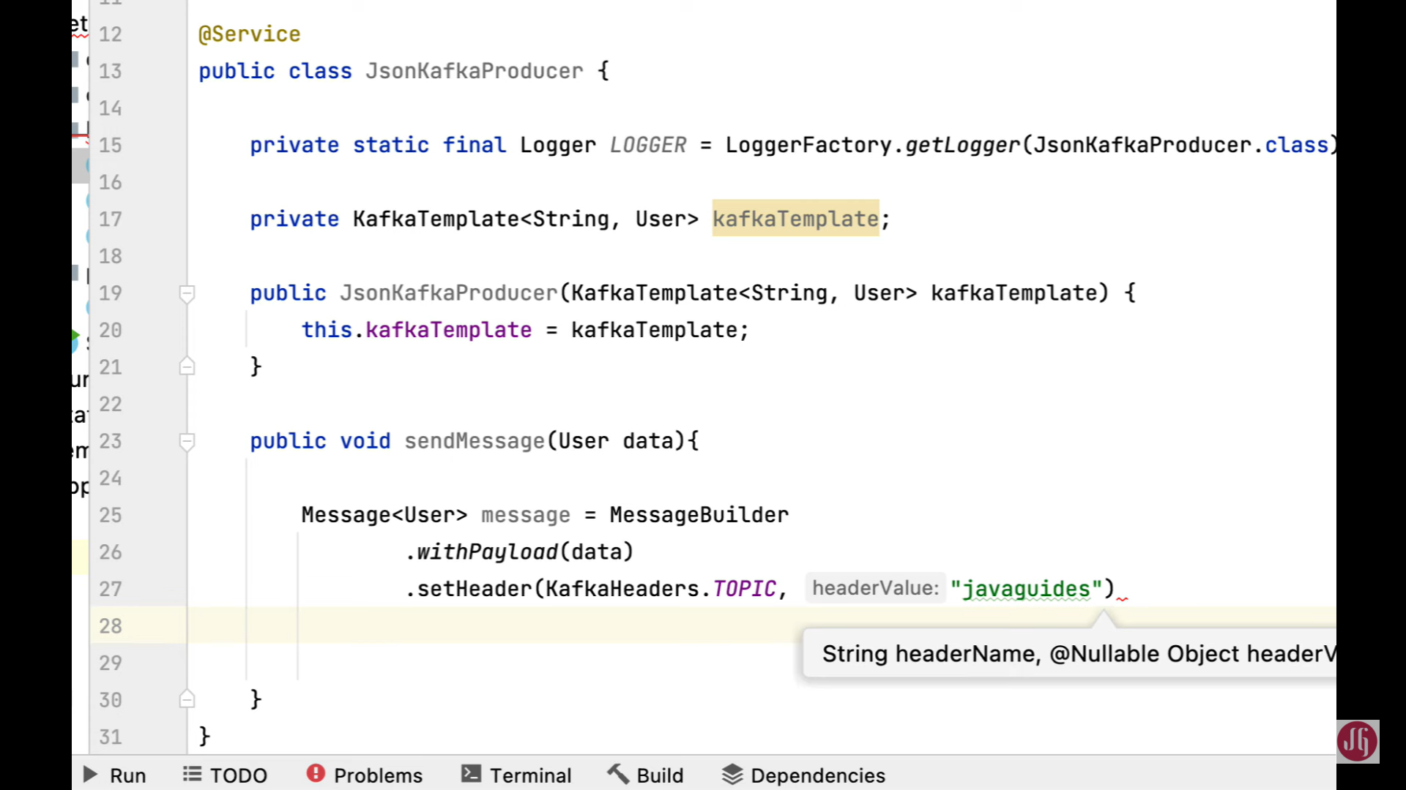

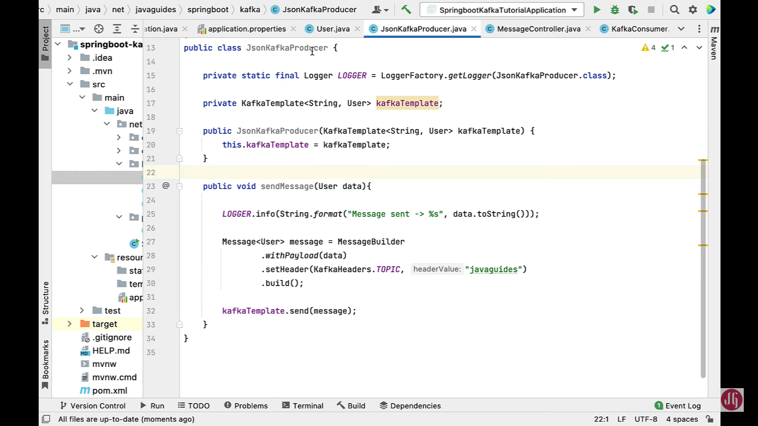

### Create REST API to Send JSON Object

we'll create a REST API to send a JSON object from the client. Well, if we can see this, you know, Kafka architecture here In previous lecture, we have created a KafkaProducer for JSON you know, serializer, right? In this lecture, we will create a simple REST API that will send a JSON object in a request, and then Kafka Producer will basically send that JSON object to the Kafka topic

right click on the controller package new and then choose a Java class and let's give class name as JsonMessageController hit enter and let's annotate this class with @RestControllerAnnotation and let's use one more annotation that is @RequestMapping annotation and then pass the base URL that is, /api/v1/kafka All right, and let's go, let's inject JsonKafkProducer so private and then JsonKafkProducer and this is kafkaProducer. And let's use constructor-based dependency injection, so let's generate the constructor. So again, we don't have to use @Autowired annotation here because this is spring bean and it has only one single parameter as constructor so spring will automatically take care of injecting this dependency.

Now next, create a method over here public and then provide a return type as a ResponseEntity and then pass the string as a type. Okay. And then let's say the method name is something like publish and then pass user object as a parameter perfect. And let's annotate this method with @PostMapping annotation. So this will basically handle HTTP POSTrequest and then provide the URL that is /publish and let's use @RequestBody annotation to convert JSON into Java object automatically. And then let's call Kafka Producer and then it's method sendMessage and then pass user object it and then simply return a ResponseEntity.Ok(" Json message sent to kafka topic"); Okay perfect. Now we have created a simple Rest endpoint which will handle HTTP POST request and it will process the JSON object from the HTTP request Okay, perfect. Now what we will do, we will run the spring boot application and let's see how KafkaProducer will send JSON message to the Kafka topic.

So let me stop the existing server and let me restart the spring boot application. And here you can see Spring Boot application is up and running in an embedded tomcat server on port 8080. Let's go ahead and let's use Postman Rest Client to call the REST API. So I'm going to open the postman client over here and use the HTTP Post method and then type http: localhost :8080/api/v1/kafka/publish Okay, so this is the URL. And then when you need pass JSON object in a HTTP request right. Go to the headers not headers go-to body and then raw and then choose content type as JSON and in a body, we need to pass the user JSON object Right So let's have ID so let's say "id":1, "firstName": let's say RAMESH and then user "lastName": let's say "fadatare" Okay, perfect. Let's go ahead and hit send button over here and there we go. We got a successful response that is 200 OK and the message is "Json message sent to the Kafka topic". Now, let's go ahead and let's see whether this JSON message, you know, has sent to the Kafka topic or not so we can verify it from the command line.

 So you can just type this command, okay and you can able to see this command will basically consume the message from the Kafka topic and here you can see this is the JSON object from the Kafka topic. It means that we have successfully written a Kafka Producer to produce the JSON message and send to that Kafka topic, isn't it? Now let's head over to the IntelliJ idea and if you go to console you can able to see there is an exception. So this Kafka Consumer we have created in one of the previous lectures right and this Consumer has subscribed to the topic javaguides and this javaguides topic has a, you know, the message of type string. but we have just sent to JSON right. and this consume method has a message of type string. This should be a user, right? but it has a string type. that way you can able to see the error in a console.

**So what we can do is we can basically create one more topic to send only the JSON messages. So go to KafkaTopicConfig and here let's create one more topic so let me simply copy this bean and paste it here and let's say javaguides\_json and let's change the name as well that is javaguides\_json topic.**

Now let's head over to the JSON Kafka Producer and let's change the topic name from javaguides to javaguides\_json. Now this JSON Kafka Producer will send the message to this topic that is javaguides\_json topic. Okay, now let's run the Spring Boot application, and let's see how this works. Now let me run the spring boot project and our spring boot application is up and running in an embedded on port 8080. Now, let's send the JSON I mean, let's call this REST API to JSON object in a request. So let me call the send button

there we go. Now, let's go to command line over here and here what we'll do we will simply pass the topic name that it is javaguides\_json hit enter and there we go and here you can able to see topic name javaguides\_json contains this JSON message. Okay. Now let's go to the IntelliJ idea and in a console you can never see, there are no exceptions. It means that we have created a separate Kafka topic to store the JSON messages

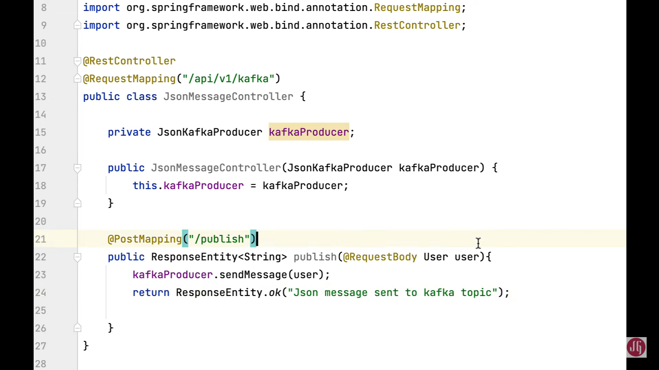

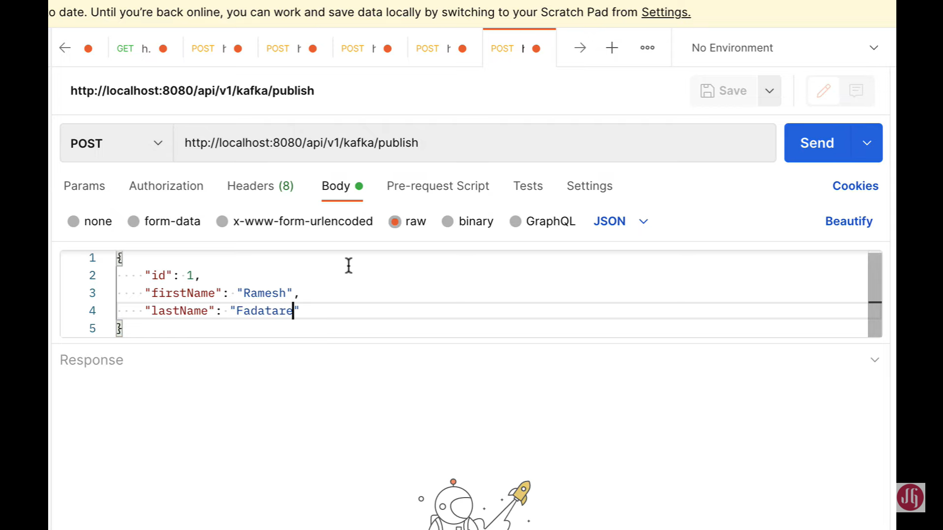 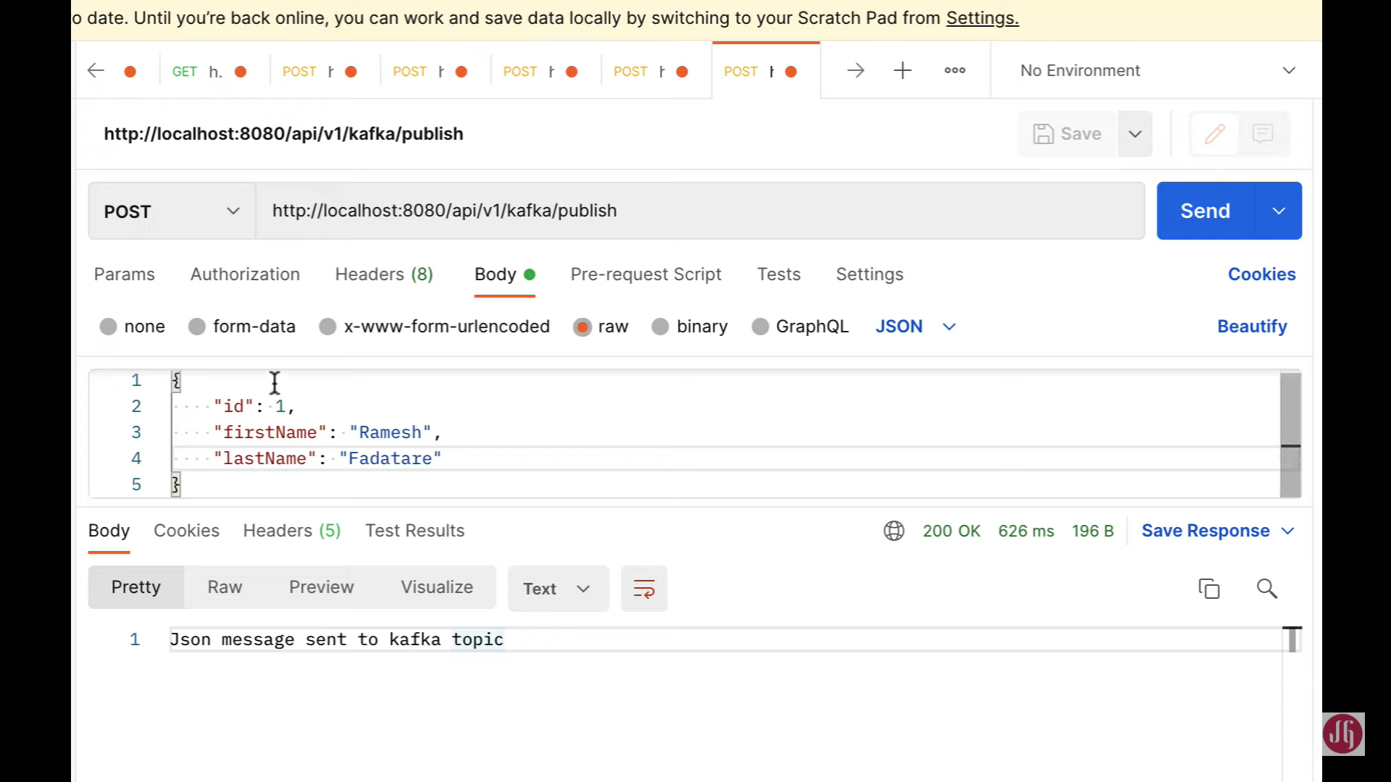

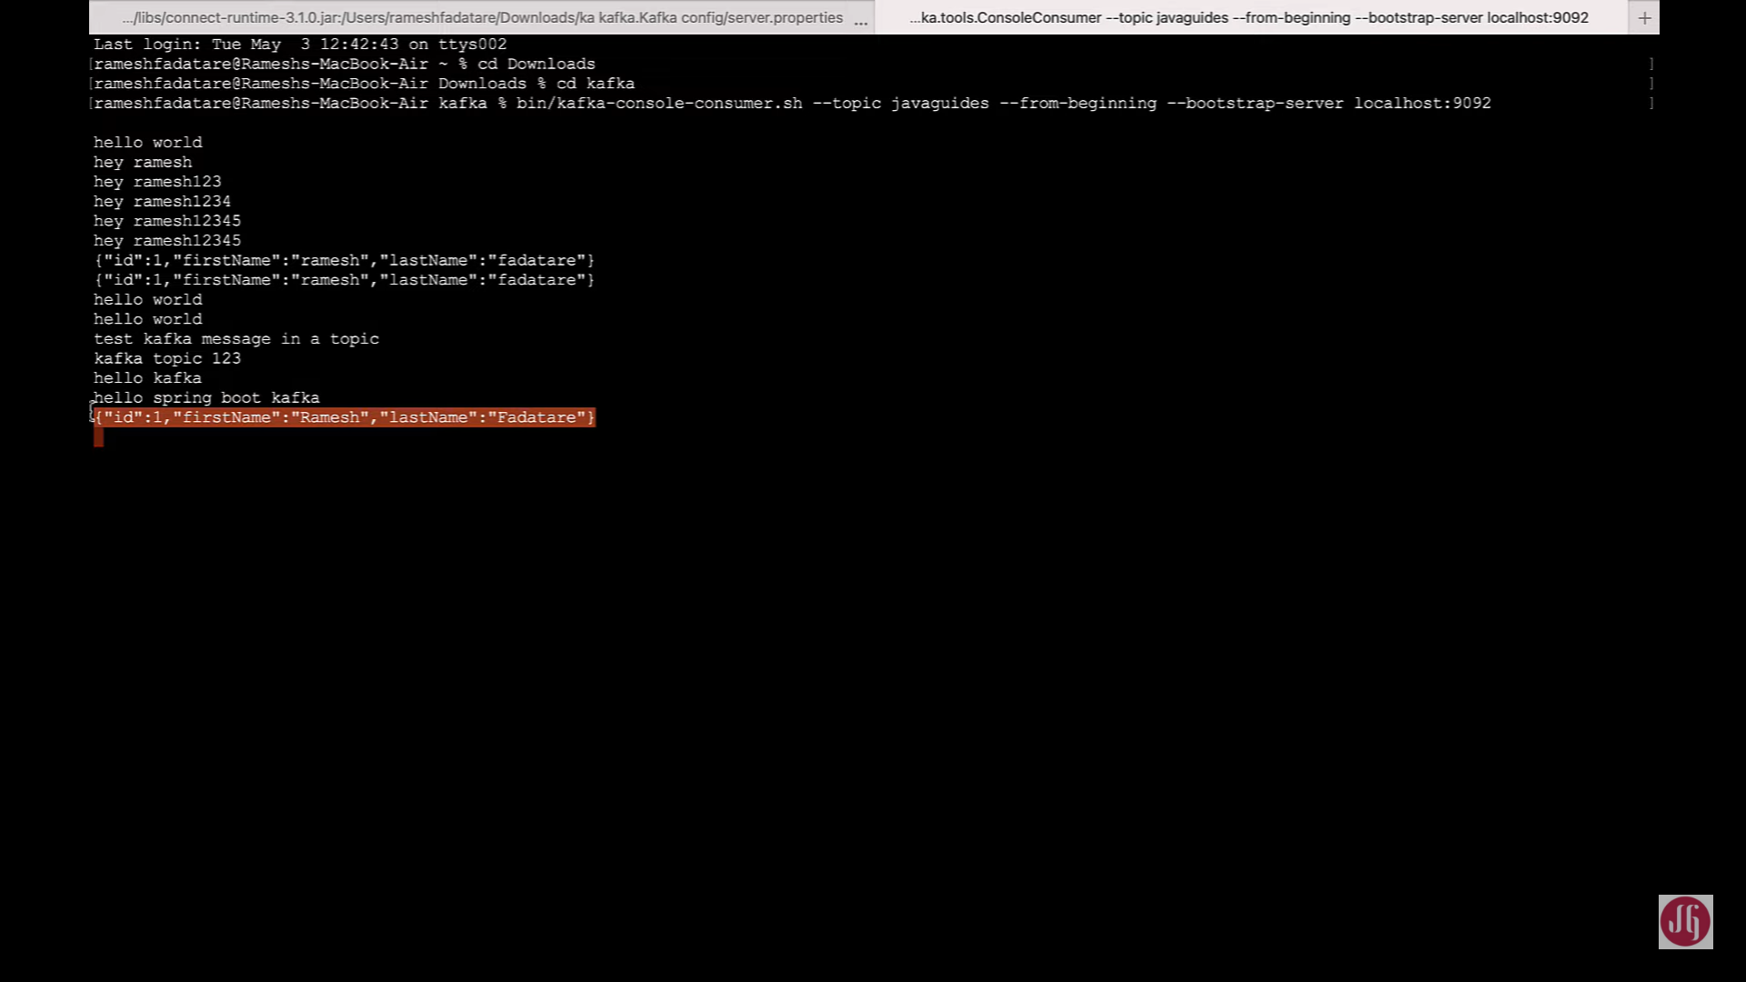 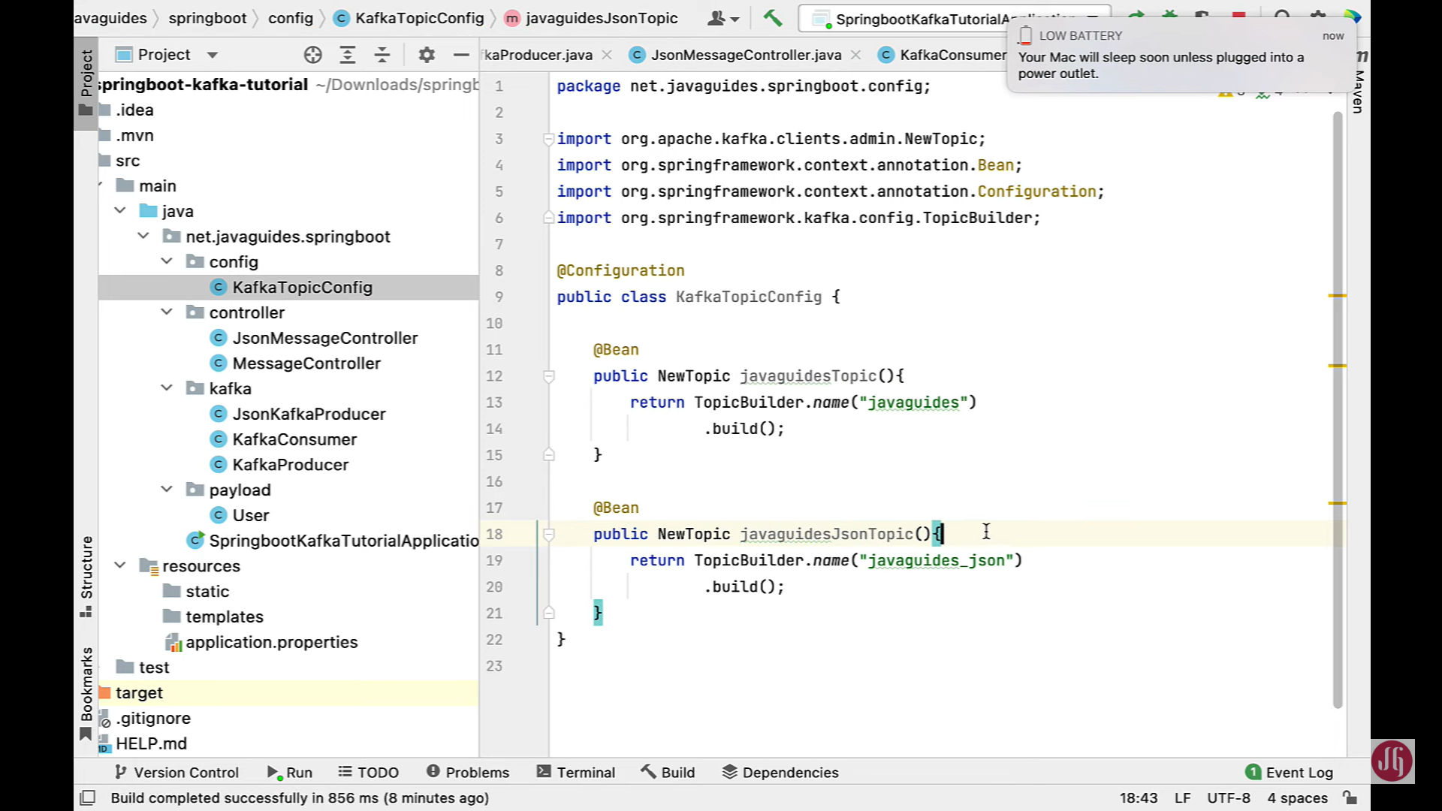

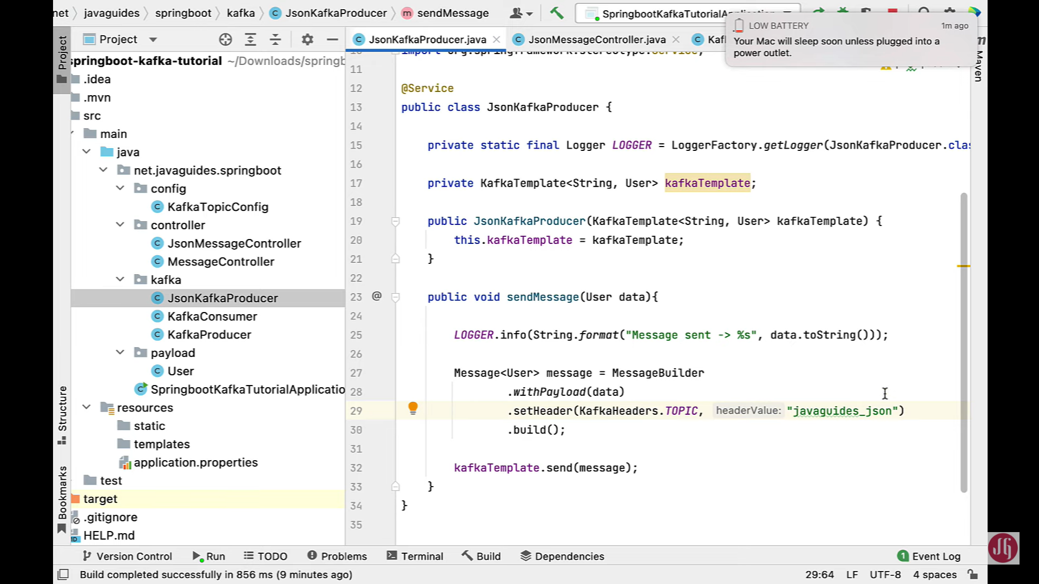

### Create Kafka Consumer to Consume JSON Message

we'll create a KafkaConsumer to consume a JSON message. Well, let's go to IntelliJ idea and go to kafka package. Right-click on it new and then choose Java class and let's give class name is JsonKafkaConsumer and hit enter and let's annotate this class with @Service annotation and let's have a Logger object here private static final and then logger from slf4j and then LOGGER LogerFactory and getLogger API and then pass class name as JsonKafkaConsumer.class. Now, we have LOGGER instance. Next, let's go ahead and let's create a method over here. Well, let's say public void and let's give method name as consume and in this case we need to pass the user object as a method parameter okay, perfect. In order to subscribe this method to the topic, we have to use annotation that is @KafkaListener annotation. So make sure that you choose @KafkaListener annotation from org.springframework.kafka.annotation package and then we need to pass the topic name. So in this case we want to use topic that is javaguides\_json and along with that we need to also pass the group-id. So we have a group-id myGroup right perfect. So what we can do is we can simply log this user object. So in order to do that, let's say logger.info this should be a logger object and then call info() method and then let's say string and then call format method and then pass message something like JSON message received and then placeholder and then pass user.toString() perfect. Now we have created KafkaConsumer to consume the JSON message all right.

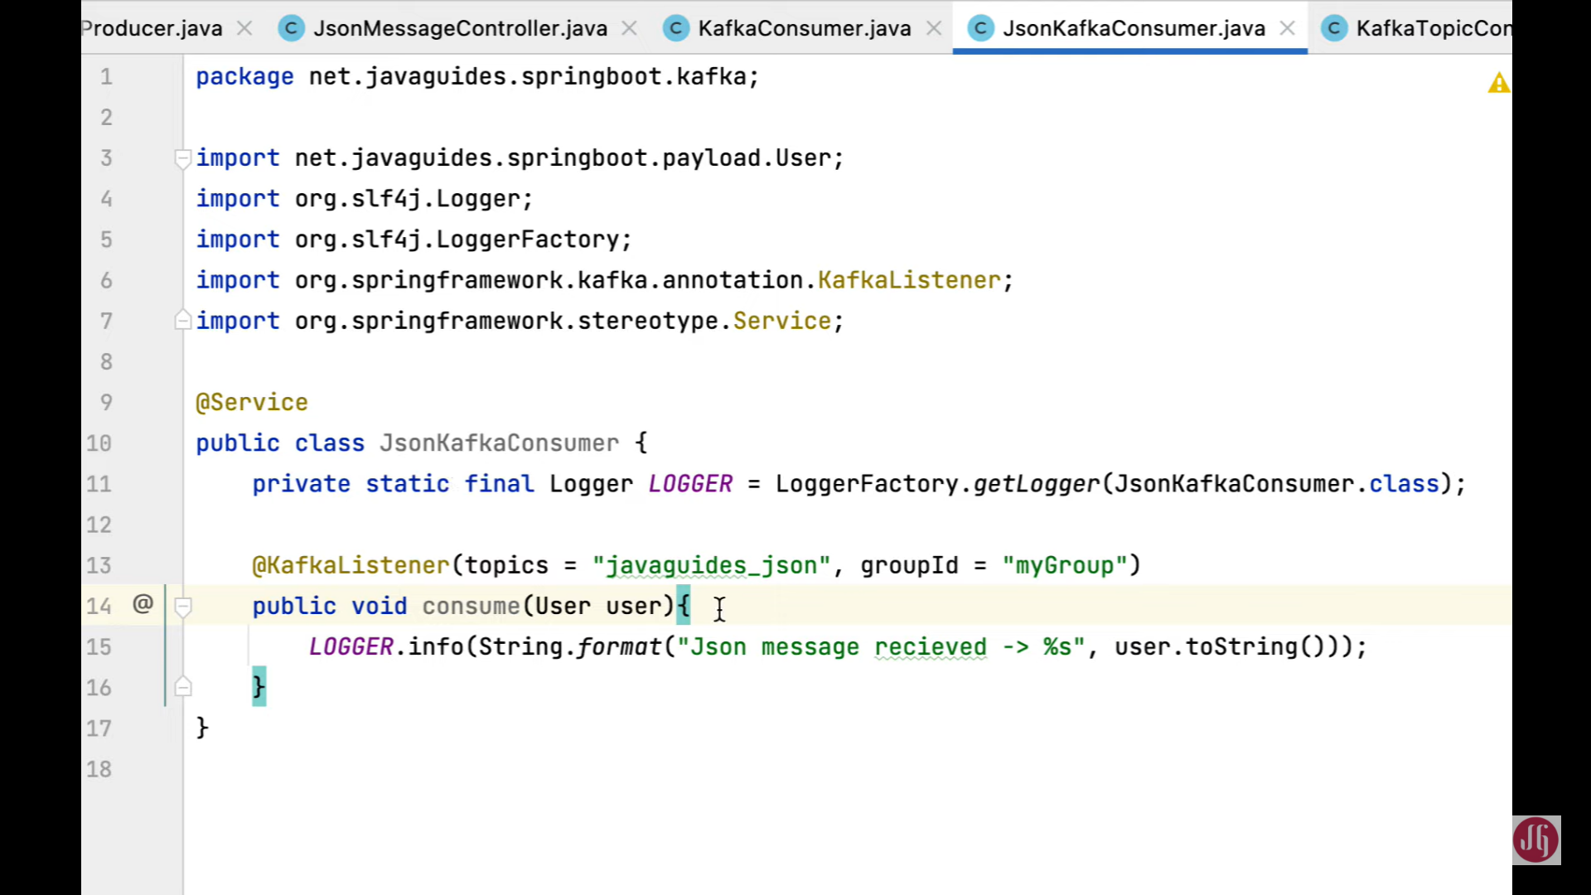

**Check with postman client**

So basically this, you know, JsonSerializer which is provided by Spring Kafka, it will basically convert Json into user object. And that user object we have simply printed using this log statement right. Now, what we can do is we can run the Spring Boot application and will verify how this KafkaConsumer will consume JSON and it will converting from JSON into user object.

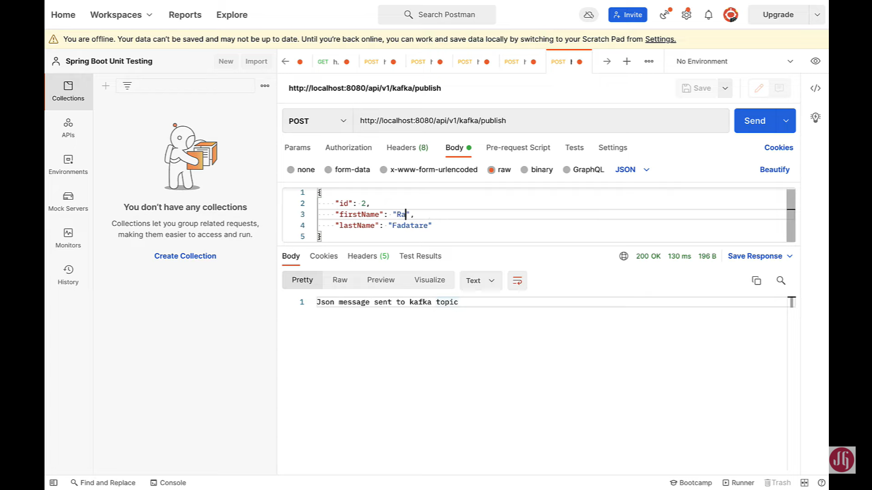

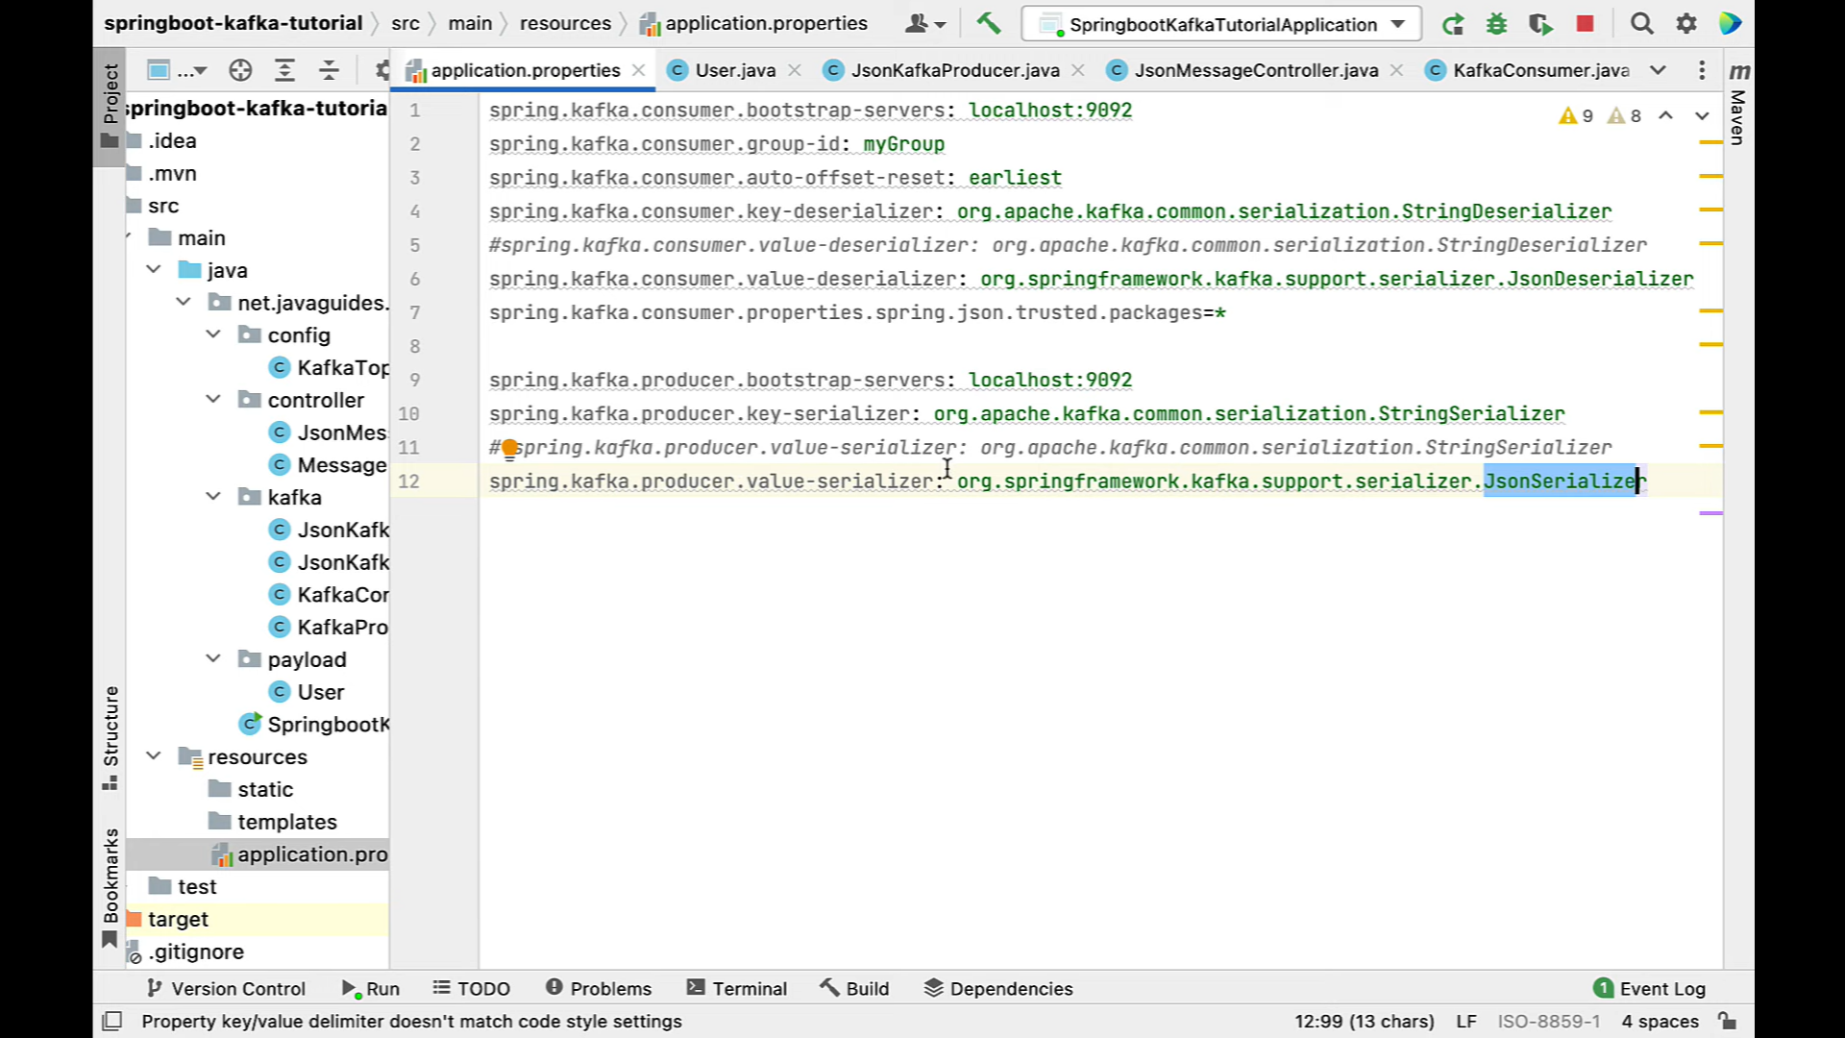

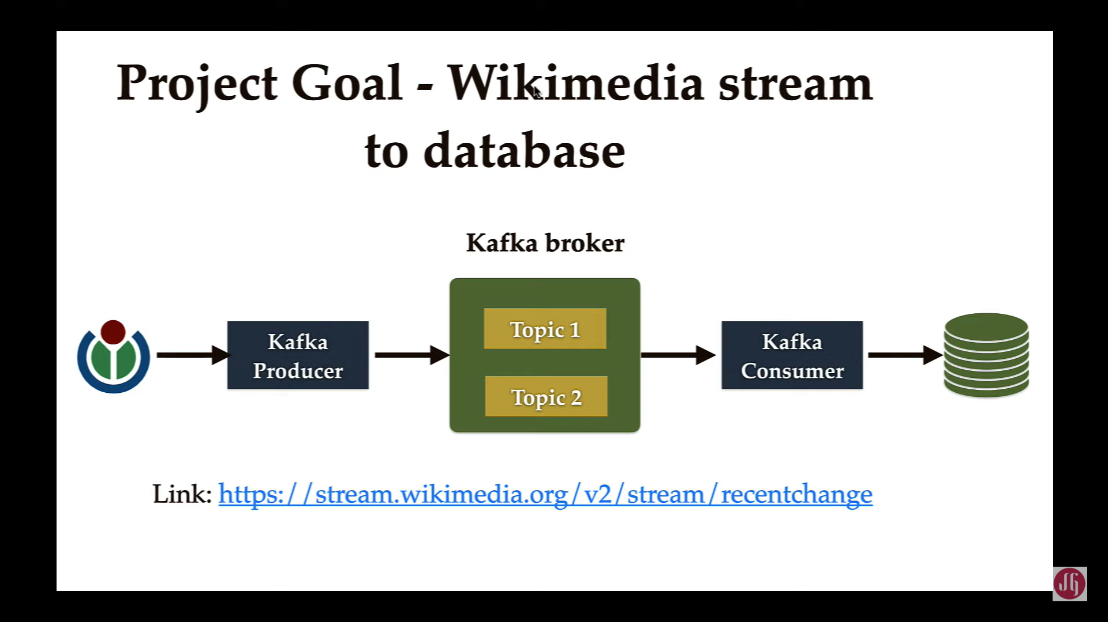

we'll take a look at the overview of a real-world project. Well, basically, we're going to develop a real-world project to demonstrate the usage of Spring Boot and Apache Kafka. Well, here is our project goal. Well, basically we're going to read a huge amount of real-time stream data from the Wikimedia to the database Okay. And if we can see the architecture, we're here. So we're going to create a Kafka producer which will read real-time stream data from the Wikimedia and then it will write that data to the Kafka broker and then we create a Kafka consumer which will consume the real-time stream data from the Kafka broker and then it will write to the database. So this is how the workflow for this project. Well, this real-world project is a best use case to demonstrate the usage of Apache Kafka, because basically, we use Apache Kafka to deal with a large amount of data Right. In this real world project, we're going to see how to create a Kafka Producer to read a large amount of real-time stream data from the Wikimedia and then it will write that data to the Kafka broker and then we'll see how to write a Kafka consumer to consume that real-time stream data from the Kafka broker and then it will write to the database. Okay,

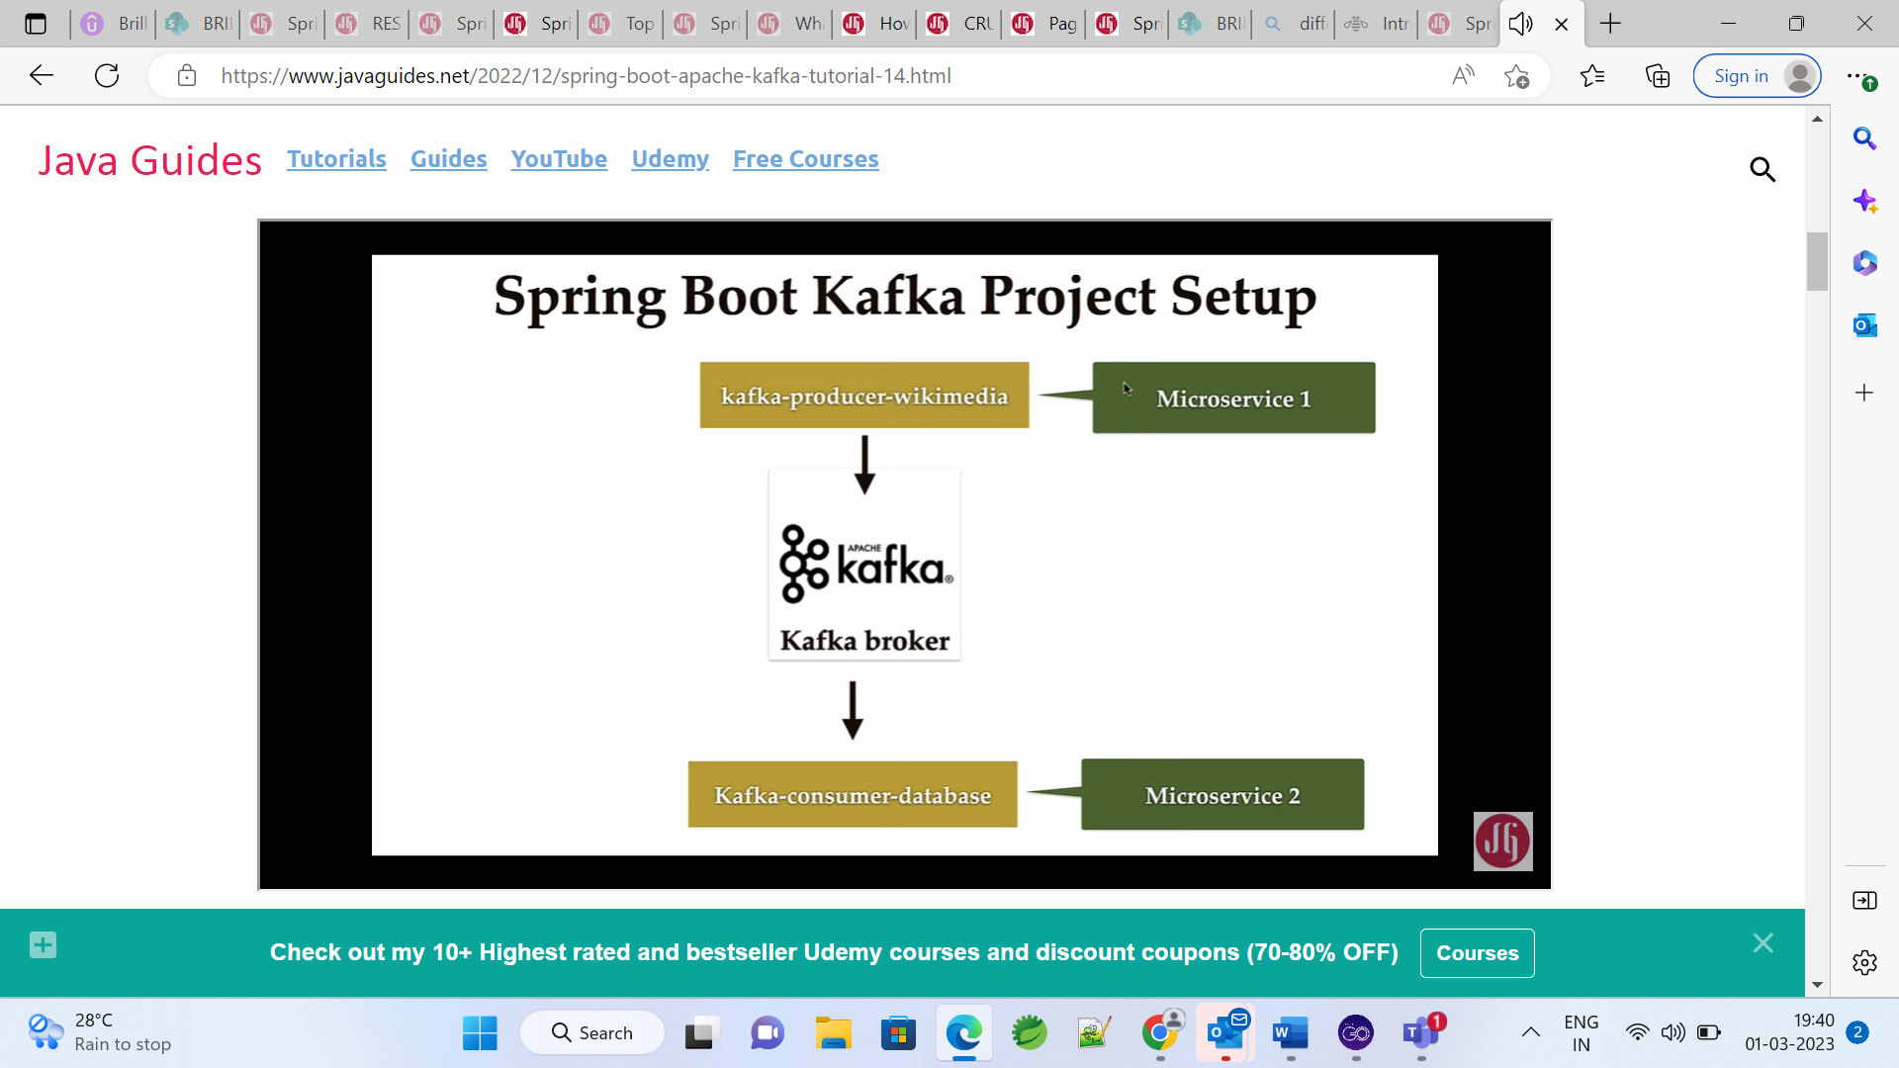

 if we can closely observe this real-time Wikimedia data, it has the events Okay. So whenever a user makes a change in the Wikimedia that the entry will be stored as an event in the Wikimedia server and by using this REST API, we can fetch all the users who made recent changes to the Wikimedia Okay. Well, let me show you a couple of demos for this real-time Wikimedia Stream data so here you can see someone has created this user interface. It behind the scene uses real time stream data Okay. You can see here the real-time data records are displayed here. So whatever the changes the user made in a given Wikimedia, those changes would be, you know, reflected over here.

# Wikimedia Producer Multi-Module Spring Boot Project

we will create Spring Boot Project for Wikimedia Producer. Well, basically we want to create a multi-module Maven project. Within that, we create a sub-modules all right. So first we'll create a Spring Boot project using spring initializr and then we'll import that project in IntelliJ idea and then we'll create sub models within that project.

 We're going to add dependencies and here we're going to choose copycat dependency for spring application. So let's type spring for capture and there we go. So this is the spring for our particular dependency, which will provide a support to integrate Apache components being based on applications. So let's choose this dependency. Okay, so it is dependencies enough for us. So also let's choose a Lombok dependency to read the boilerplate. Good. So we choose this dependency.

now we have generated Spring Boot application using Spring Slider and importing that project in line to JDA. Let's make this Spring Boot project as a multi-module mapping project. Okay, so let's go and let's make the necessary changes to make this project as a multi module, my own project. So first of all, we need to make this project as a parent project, right? So go to the word excel and we need to add a packaging that we're here. So just add a packaging tag and let's go value adds. POM Okay, so whenever we create a multimode in my own project we have to provide packaging type as a bomb for a parent project. Okay, now we are going to create a sub models within this parent project. Okay? Just save it and just go to this icon here and just order my oranges. Okay? Now the parent project is ready. Now let's go ahead and execute the module within this parent project. So right click on this project new and then choose model and take this and then click on next and then go model name as cub co-producer Wikimedia and then we can finish. So this will create the model within this.

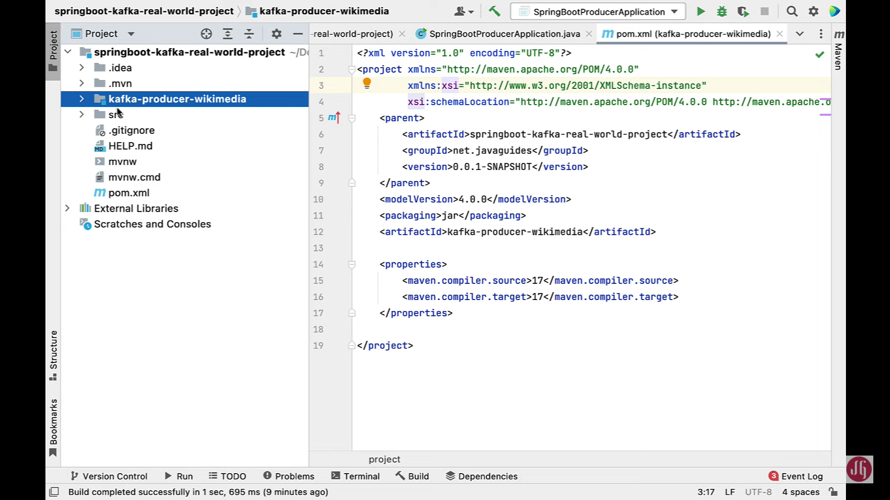

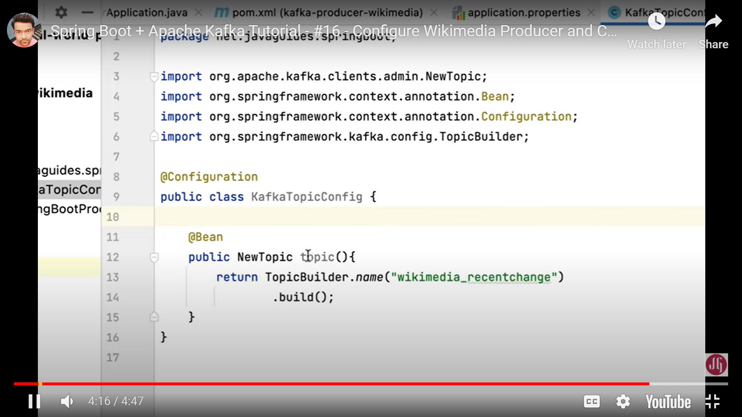 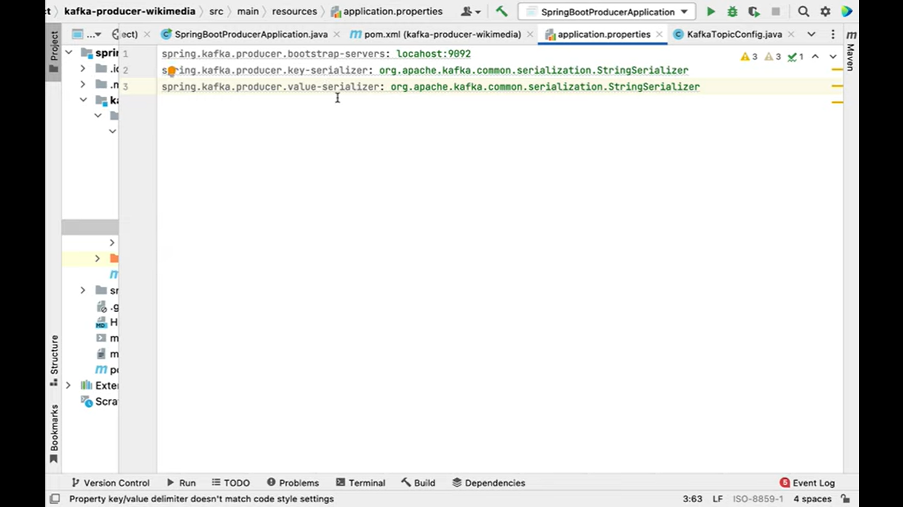

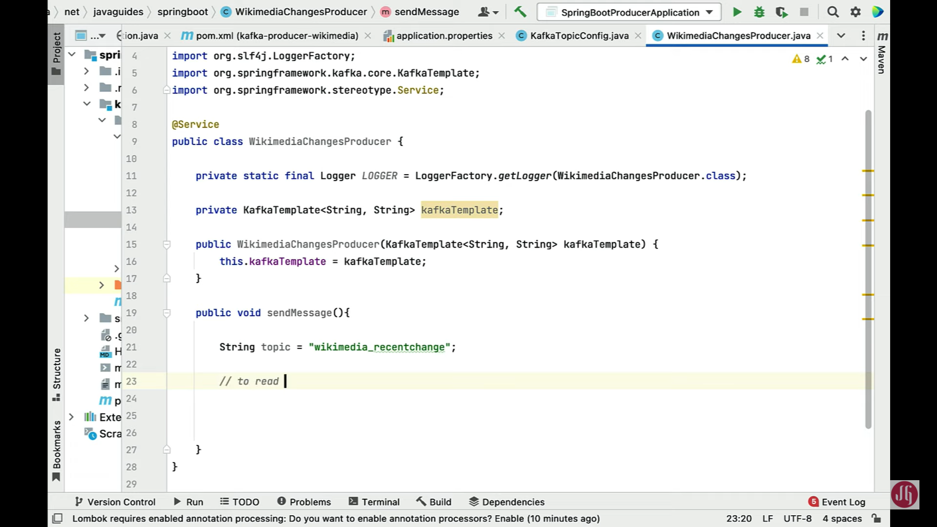

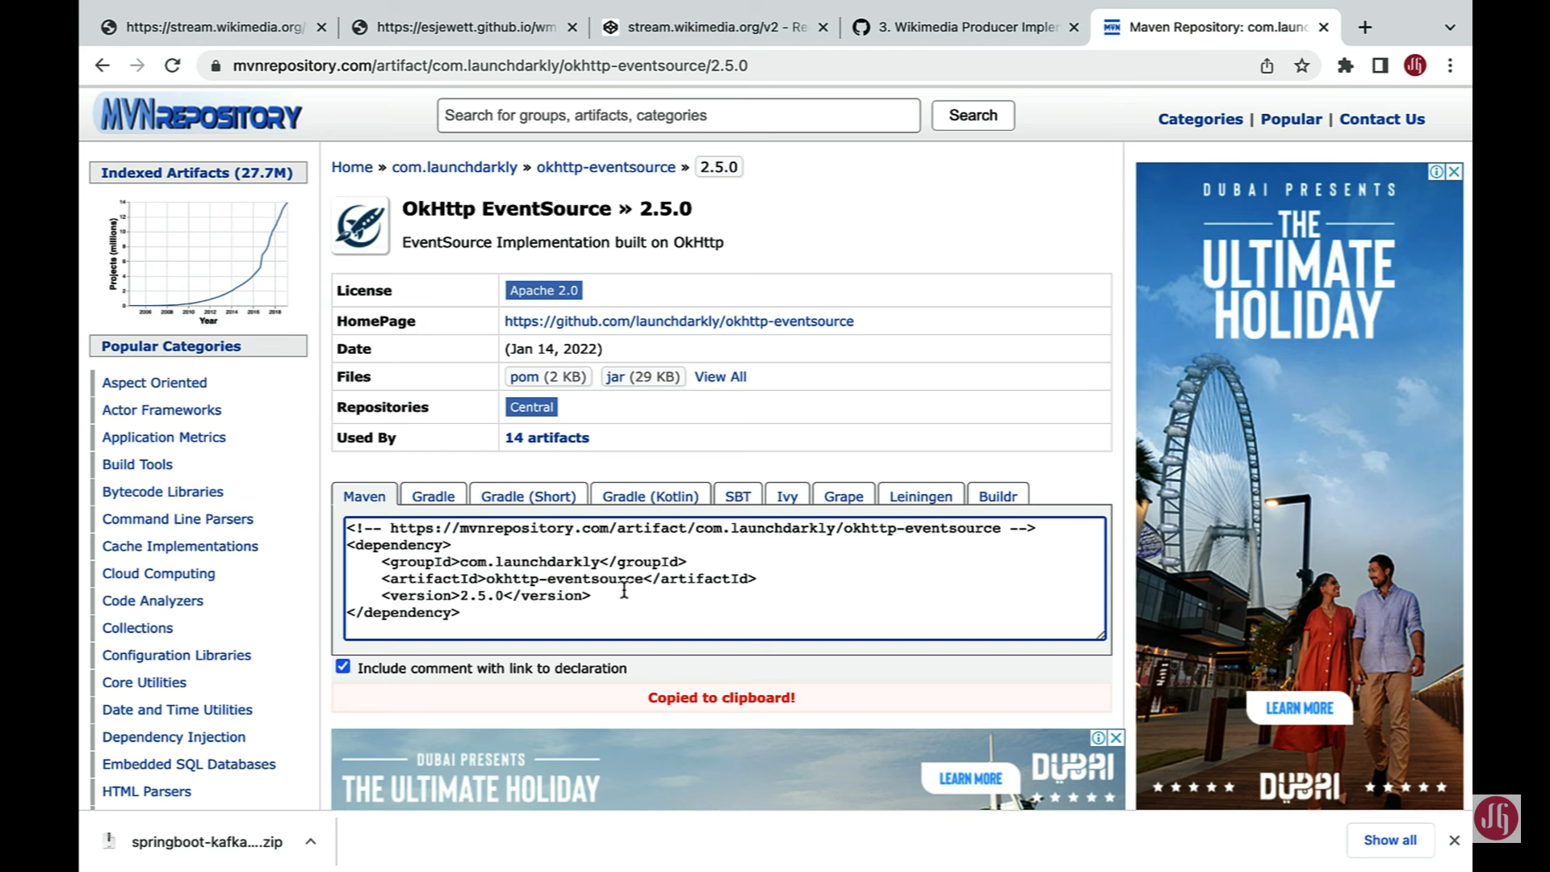

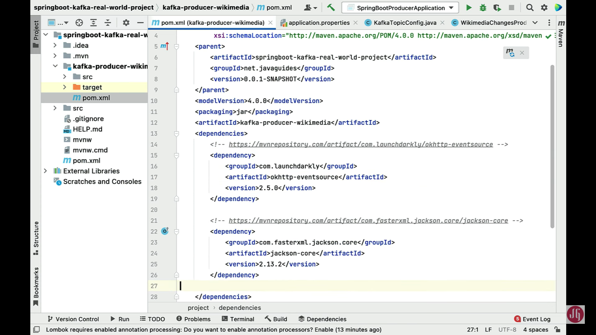 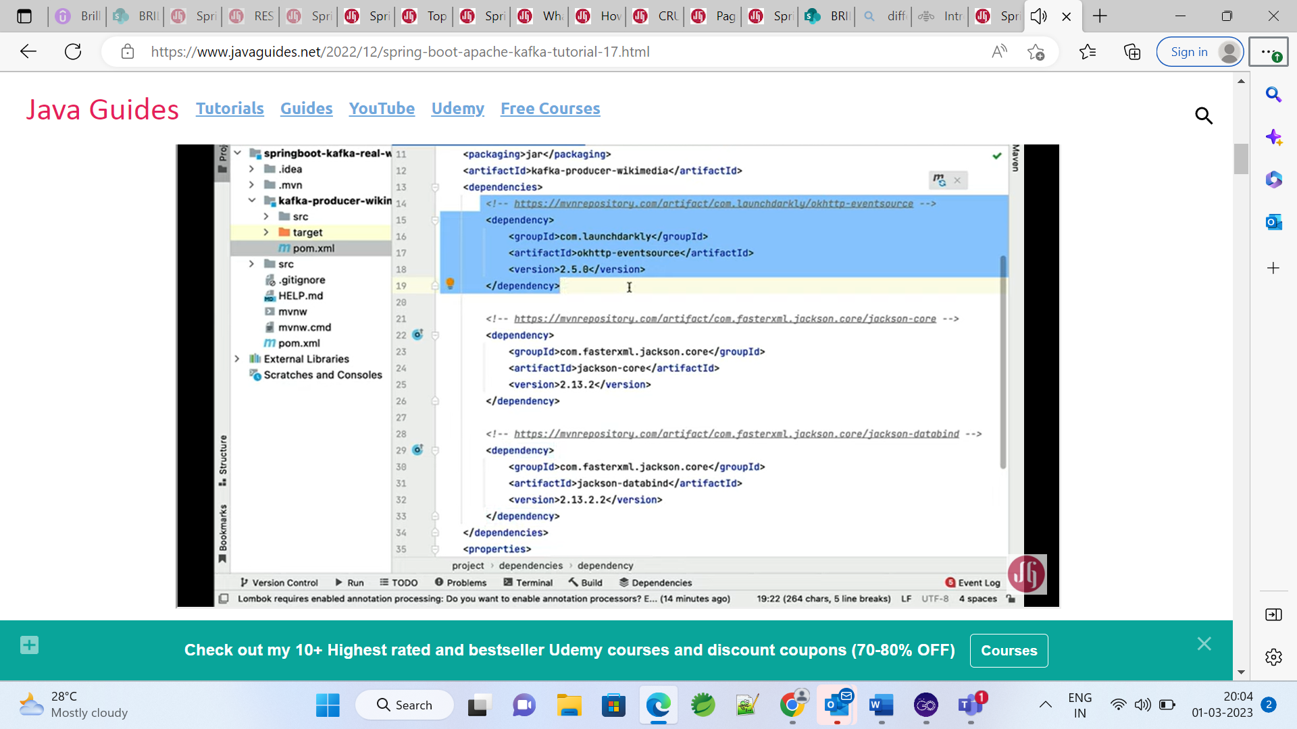

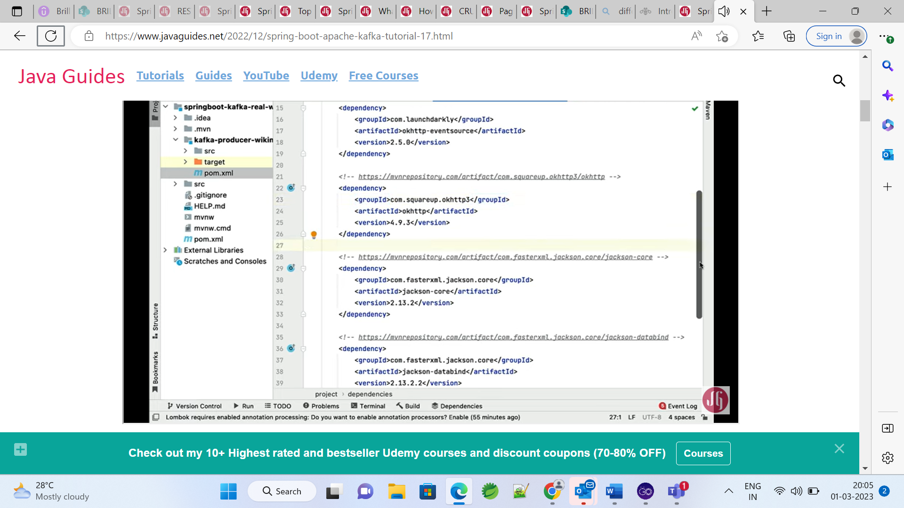

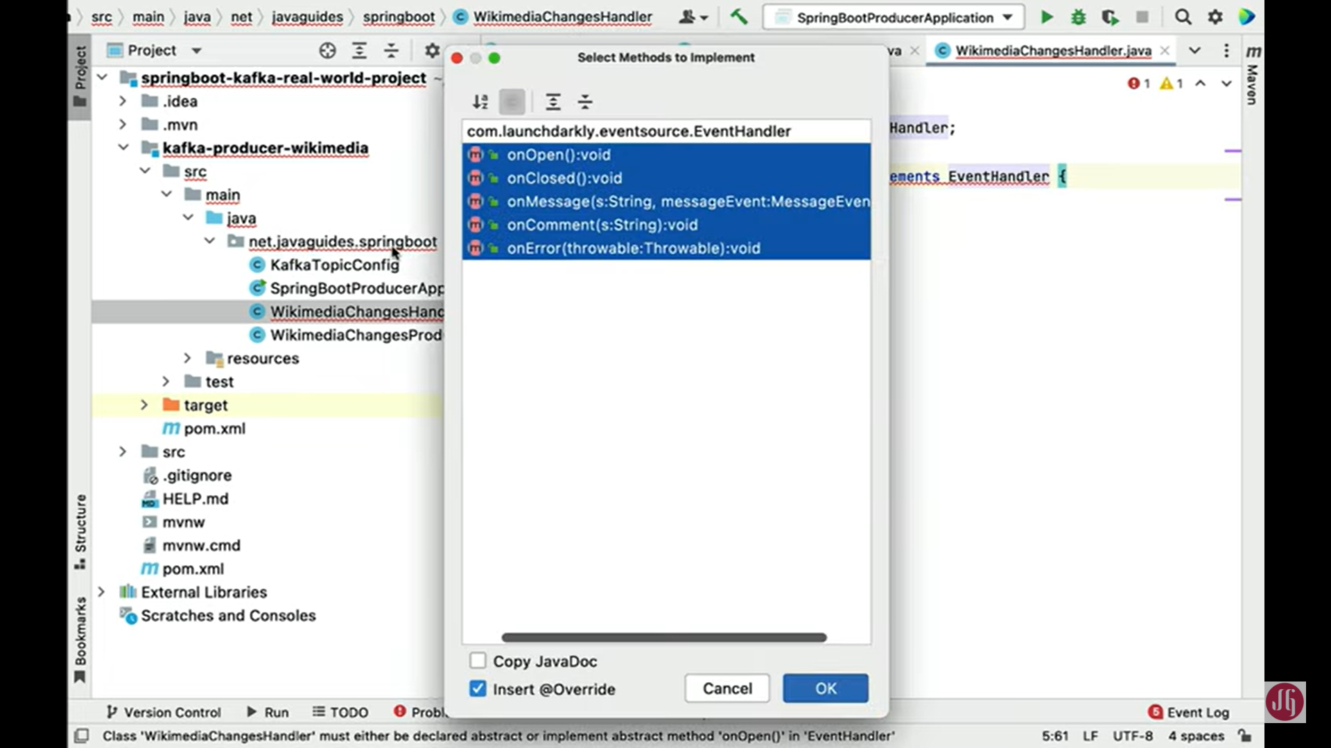

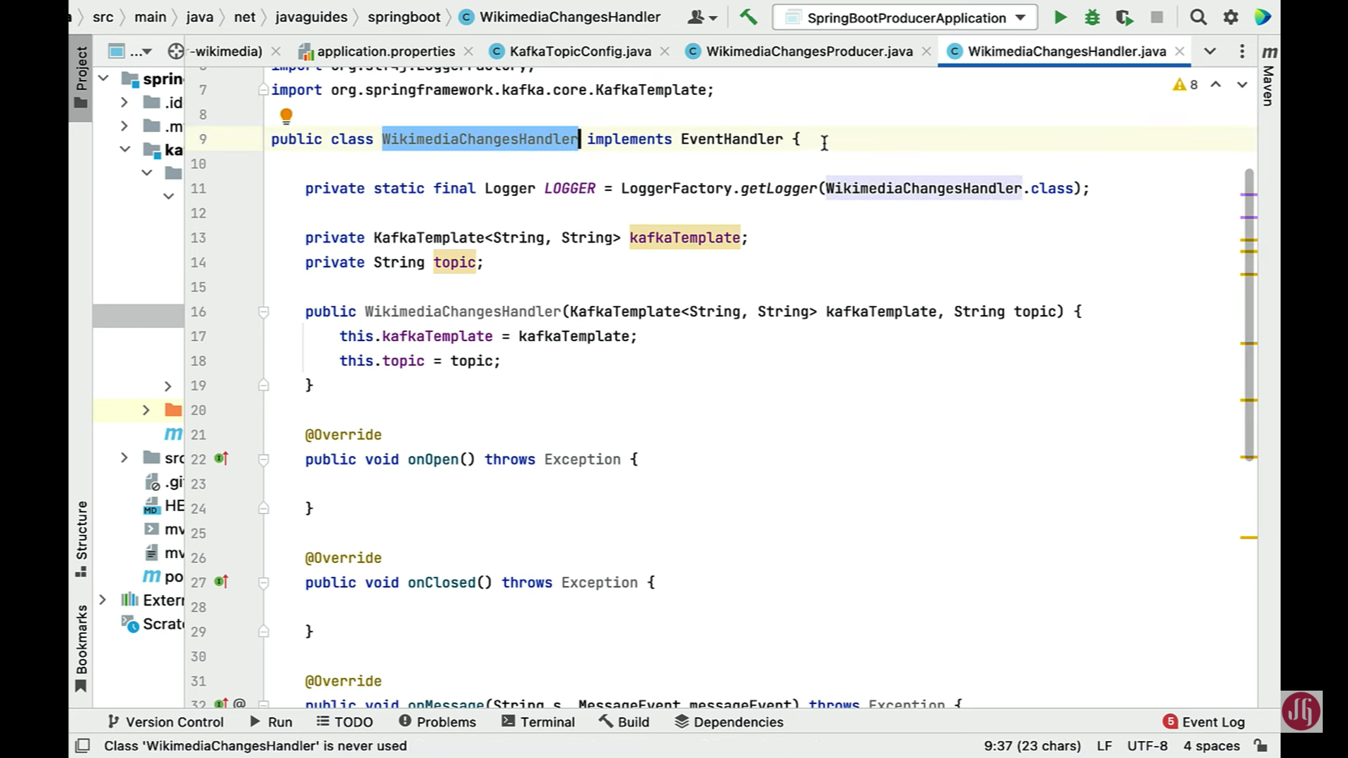

[Spring Boot + Apache Kafka Tutorial - #17 - Wikimedia Producer and Event Handler Implementation (javaguides.net)](https://www.javaguides.net/2022/12/spring-boot-apache-kafka-tutorial-17.html)

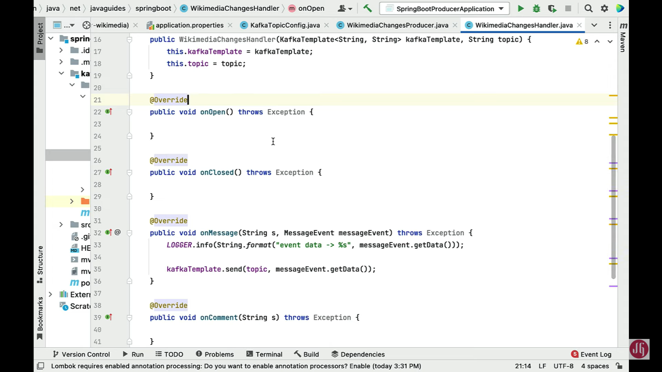

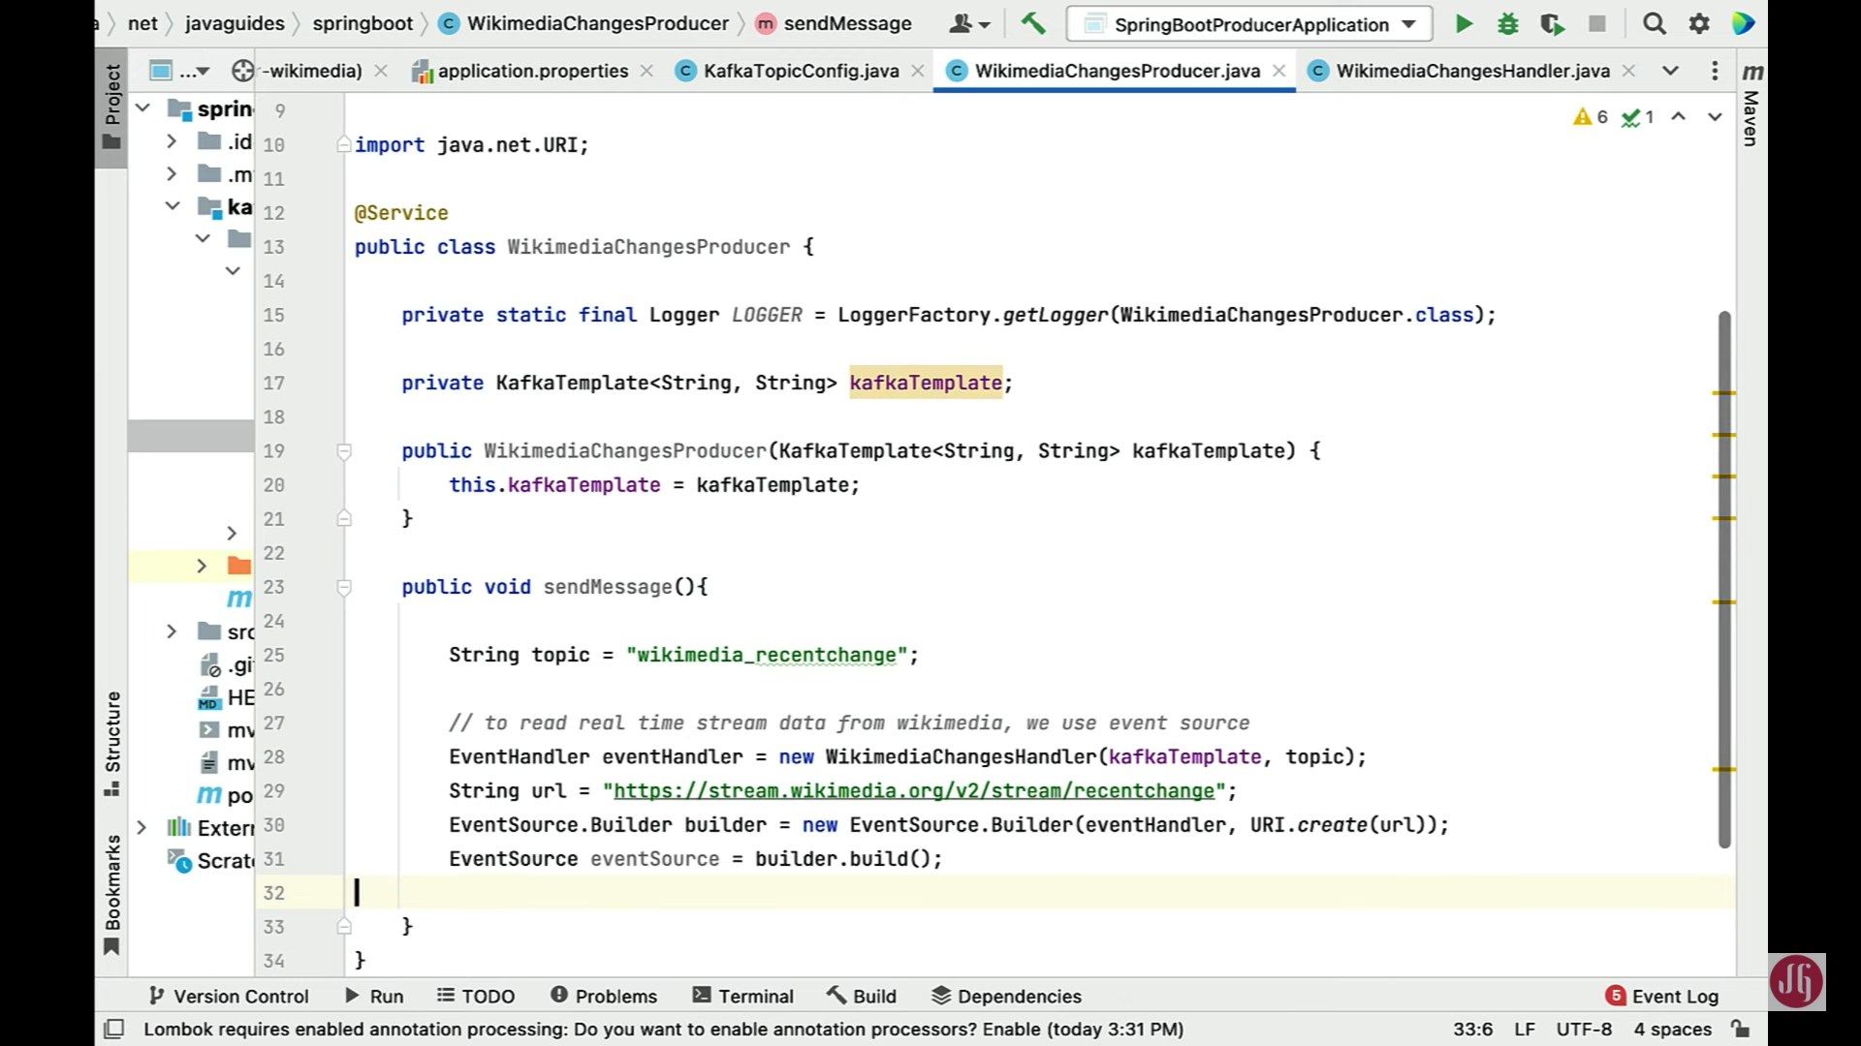

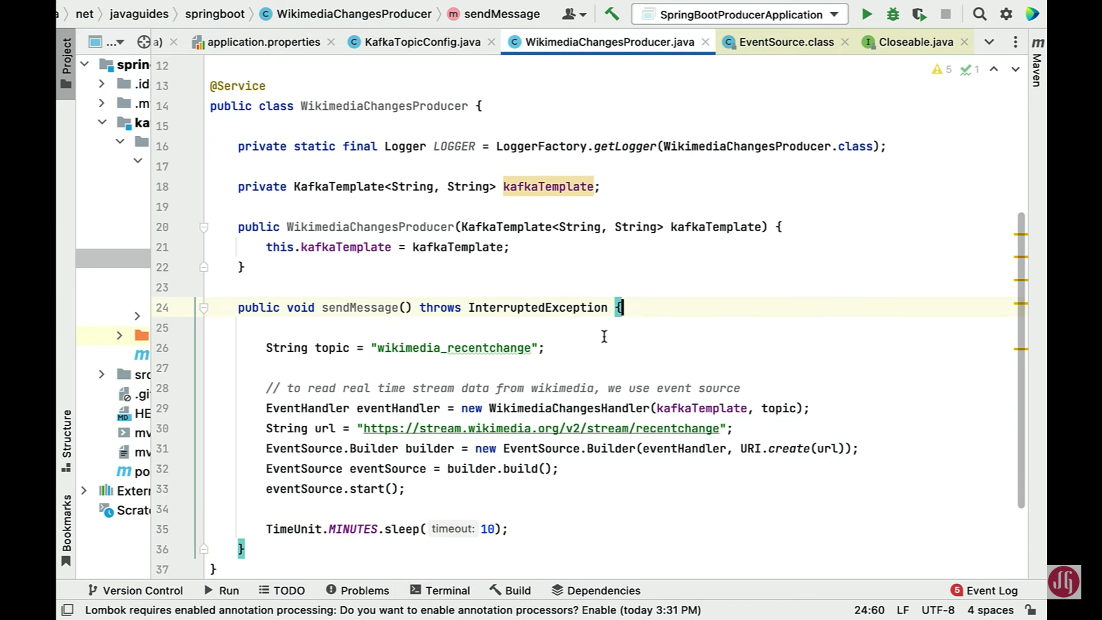 Now let's go back to our producer class that is Wikimedia and is polluted. So within this producer, we are going to call this Wikimedia unit handler class. Let's create a new internal object. So let's type. You intend to make sure that you choose you in general from come dot launch directly dot event source package and then this should be a you intend to call to new and then call the implementation class that is cumulative agenda and then pass post parameter as the capture template second parameter as the topic public. Now we have created you and handler. Next, we need to define the event source, whatever that is. First, happy with it. So let me simply copy that detail from here. So this is the recipe within it provides real time accumulate stream data. Right. So let me copy this link and let me pass here by. Right now we need to pass this other to the event source. Next we need to create a new insert which will basically connect to the source that is Wikimedia source and it will read although you ended up. So let's create the event source and make sure that your juju ensures problem cannot launched. Actually not even source package and then call builder. So first we need to create a builder event source builder and then we create the event source object from doing so, build it next new and then you insert dot builder and then you intend to add a push. Parameters are confirmed as the order. So just call you whatever dot create and then pass you all by now we operator event source builder. No not creator. Event source object from this builder. So let's say you insert and then you're in search of critical builder dot build method. Perfect. We have created you into source object. Well, if we can see the internal implementation, even tender event handler internally uses executable service to create threads. Okay. So now what we need to do is we need to, you know, start this event source in a separate thread. So just call your answer. Dot, dot. Okay, perfect. I'm going to provide the slip. Slip for 10 minutes. So just call minutes and then call slip and then 10 minutes. Okay. After 10 minutes. They should be stopped. Okay, so let me see what they are here. So this should be. So this should handle this exception. Okay, perfect. Now, what we have done, basically, we have created a Wikimedia genius handler. So this handler will be triggered whenever there is a, you know, Wikimedia, and then this event source will basically connect to the source that is Wikimedia source. And the source is this. And then this event source will pull all the realtime stream data from this source and then it will trigger the respective handler. Okay. And then within a handler, we have written a code to send that event to the topic. Isn't it?

# Run and Test Wikimedia Producer

### Graphical user interface, text Description automatically generated Create Kafka Consumer Project | Configure Kafka Consumer

[Spring Boot + Apache Kafka Tutorial - #19 - Create Kafka Consumer Project | Configure Kafka Consumer (javaguides.net)](https://www.javaguides.net/2022/12/spring-boot-apache-kafka-tutorial-19.html)

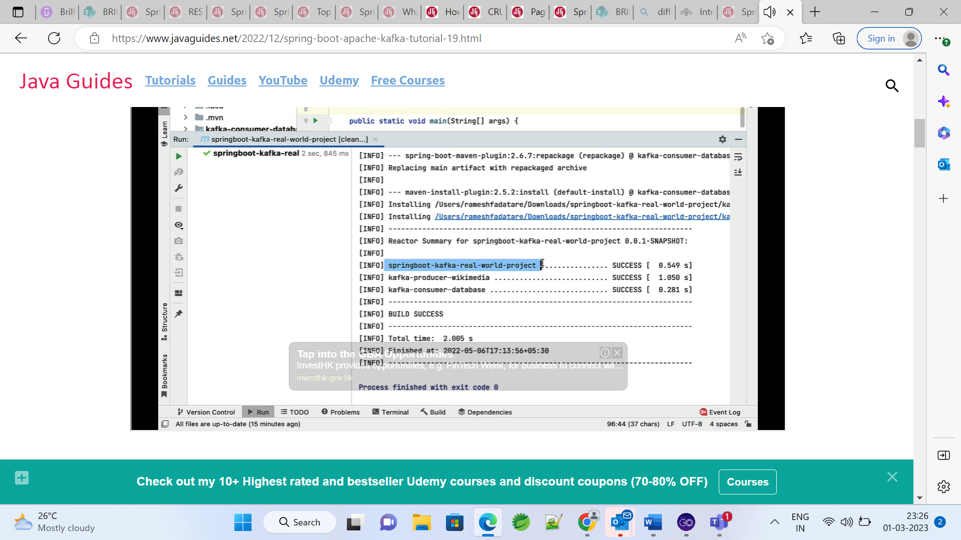 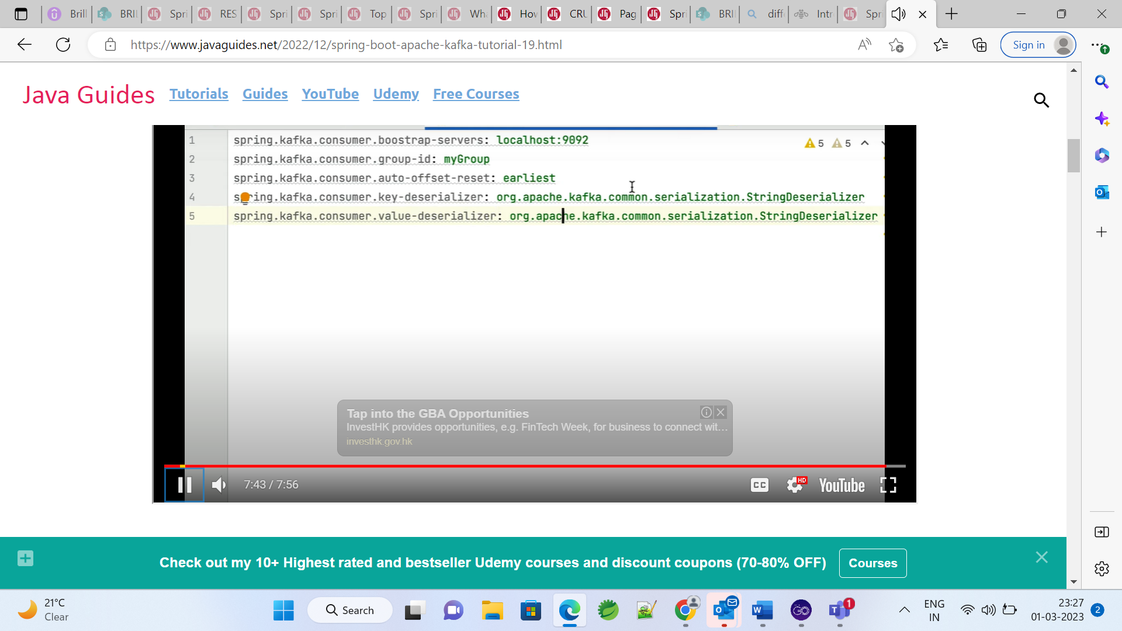

# Configure MySQL Database

## **Basic Kafka Interview Questions**

Let us begin with the basic Kafka interview questions!

### **1. What is the role of the offset?**

In partitions, messages are assigned a unique ID number called the offset. The role is to identify each message in the partition uniquely.

### **2. Can Kafka be used without ZooKeeper?**

It is not possible to connect directly to the Kafka Server by bypassing ZooKeeper. Any client request cannot be serviced if ZooKeeper is down.

### **3. In Kafka, why are replications critical?**

Replications are critical as they ensure published messages can be consumed in the event of any program error or machine error and are not lost.

### **4. What is a partitioning key?**

Ans. The partitioning key indicates the destination partition of the message within the producer. A hashing based partitioner determines the partition ID when the key is given.

### **5. What is the critical difference between Flume and Kafka?**

Kafka ensures more durability and is scalable even though both are used for real-time processing.

### **6. When does QueueFullException occur in the producer?**

QueueFullException occurs when the producer attempts to send messages at a pace not handleable by the broker.

### **7. What is a partition of a topic in Kafka Cluster?**

Partition is a single piece of Kafka topic. More partitions allow excellent parallelism when reading from the topics. The number of partitions is configured based on per topic.

### **8. Explain Geo-replication in Kafka.**

The Kafka MirrorMaker provides Geo-replication support for clusters. The messages are replicated across multiple cloud regions or datacenters. This can be used in passive/active scenarios for recovery and backup.

### **9. What do you mean by ISR in Kafka environment?**

ISR is the abbreviation of In sync replicas. They are a set of message replicas that are synced to be leaders.

### **10. How can you get precisely one messaging during data production?**

To get precisely one messaging from data production, you have to follow two things avoiding duplicates during data production and avoiding duplicates during data consumption. For this, include a primary key in the message and de-duplicate on the consumer.

### **11. How do consumers consumes messages in Kafka?**

The transfer of messages is done in Kafka by making use of send file API. The transfer of bytes occurs using this file through the kernel-space and the calls between back to the kernel and kernel user.

### **12. What is Zookeeper in Kafka?**

One of the basic Kafka interview questions is about Zookeeper. It is a high performance and open source complete coordination service used for distributed applications adapted by Kafka. It lets Kafka manage sources properly.

### **13. What is a replica in the Kafka environment?**

The replica is a list of essential nodes needed for logging for any particular partition. It can play the role of a follower or leader.

### **14. What does follower and leader in Kafka mean?**

Partitions are created in Kafka based on consumer groups and offset. One server in the partition serves as the leader, and one or more servers act as a follower. The leader assigns itself tasks that read and write partition requests. Followers follow the leader and replicate what is being told.

### **15. Name various components of Kafka.**

The main components are:

1. Producer – produces messages and can communicate to a specific topic
2. Topic: a bunch of messages that come under the same topic
3. Consumer: One who consumes the published data and subscribes to different topics
4. Brokers: act as a channel between consumers and producers.

### **16. Why is Kafka so popular?**

Kafka acts as the central nervous system that makes streaming data available to applications. It builds real-time data pipelines responsible for data processing and transferring between different systems that need to use it.

### **17. What are consumers in Kafka?**

Kafka tags itself with a user group, and every communication on the topic is distributed to one use case. Kafka provides a single-customer abstraction that discovers both publish-subscribe consumer group and queuing.

### **18. What is a consumer group?**

When more than one consumer consumes a bunch of subscribed topics jointly, it forms a consumer group.

### **19. How is a Kafka Server started?**

To start a Kafka Server, the Zookeeper has to be powered up by using the following steps:

> bin/zookeeper-server-start.sh config/zookeeper.properties

> bin/kafka-server-start.sh config/server.properties

### **20. How does Kafka work?**

Kafka combines two messaging models, queues them, publishes, and subscribes to be made accessible to several consumer instances.

### **21. What are replications dangerous in Kafka?**

This is because duplication assures that issued messages are absorbed in plan fault, appliance mistake or recurrent software promotions.

### **22. What is the role of Kafka Producer API play?**

It covers two producers: kafka.producer.async.AsyncProducer and kafka.producer.SyncProducer. The API provides all producer performance through a single API to its clients.

### **23. Discuss the architecture of Kafka.**

A cluster in Kafka contains multiple brokers as the system is distributed. The topic in the system is divided into multiple partitions. Each broker stores one or multiple partitions so that consumers and producers can retrieve and publish messages simultaneously.

### **24. What advantages does Kafka have over Flume?**

Kafka is not explicitly developed for Hadoop. Using it for writing and reading data is trickier than it is with Flume. However, Kafka is a highly reliable and scalable system used to connect multiple systems like Hadoop.

#### Your Data Science Career Starts Today!

Caltech Post Graduate Program in Data Science[EXPLORE PROGRAM](https://www.simplilearn.com/post-graduate-program-data-science?source=GhPreviewCTABanner)

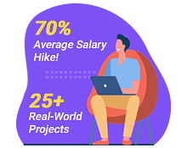

### **25. Why are the benefits of using Kafka?**

Kafka has the following advantages:

1. Scalable- Data is streamlined over a cluster of machines and partitioned to enable large information.
2. Fast- Kafka has brokers which can serve thousands of clients
3. Durable- message is replicated in the cluster to prevent record loss.
4. Distributed- provides robustness and fault tolerance.

## **Advanced Kafka Interview Questions**

In the next section let us have a look at the advanced Kafka interview questions.

### **1. Is getting message offset possible after producing?**

This is not possible from a class behaving as a producer because, like in most queue systems, its role is to forget and fire the messages. As a message consumer, you get the offset from a Kaka broker.

### **2. How can the Kafka cluster be rebalanced?**

When a customer adds new disks or nodes to existing nodes, partitions are not automatically balanced. If several nodes in a topic are already equal to the replication factor, adding disks will not help in rebalancing. Instead, the Kafka-reassign-partitions command is recommended after adding new hosts.

### **3. How does Kafka communicate with servers and clients?**

The communication between the clients and servers is done with a high-performance, simple, language-agnostic TCP protocol. This protocol maintains backwards compatibility with the earlier version.

### **4. How is the log cleaner configured?**

It is enabled by default and starts the pool of cleaner threads. For enabling log cleaning on particular topic, add: log.cleanup.policy=compact. This can be done either by using alter topic command or at topic creation time.

### **5. What are the three broker configuration files?**

The essential configuration files are broker.id, log.dirs, zookeeper.connect.

### **6. What are the traditional methods of message transfer?**

The traditional method includes:

1. Queuing- a pool of consumers read a message from the server, and each message goes to one of the consumers.
2. Publish-subscribe: Messages are broadcasted to all consumers.

### **7. What is a broker in Kafka?**

The broker term is used to refer to Server in Kafka cluster.

### **8. What maximum message size can the Kafka server receive?**

The maximum message size that Kafka server can receive is 10 lakh bytes.

### **9. How can the throughput of a remote consumer be improved?**

If the consumer is not located in the same data center as the broker, it requires tuning the socket buffer size to amortize the long network latency.

#### Learn Everything You Need To Know About Data!

Data Engineering Certification Program[EXPLORE COURSE](https://www.simplilearn.com/pgp-data-engineering-certification-training-course?source=GhPreviewCTABanner)



### **10. How can churn be reduced in ISR, and when does the broker leave it?**

ISR has all the committed messages. It should have all replicas till there is a real failure. A replica is dropped out of ISR if it deviates from the leader.

### **11. If replica stays out of ISR for a long time, what is indicated?**

If a replica is staying out of ISR for a long time, it indicates the follower cannot fetch data as fast as data is accumulated at the leader.

### **12. What happens if the preferred replica is not in the ISR?**

The controller will fail to move leadership to the preferred replica if it is not in the ISR.

### **13. What is meant by SerDes?**

SerDes (Serializer and Deserializer) materializes the data whenever necessary for any Kafka stream when SerDes is provided for all record and record values.

### **14. What do you understand by multi-tenancy?**

This is one of the most asked advanced Kafka interview questions. Kafka can be deployed as a multi-tenant solution. The configuration for different topics on which data is to be consumed or produced is enabled.

### **15. How is Kafka tuned for optimal performance?**

To tune Kafka, it is essential to tune different components first. This includes tuning Kafka producers, brokers and consumers.

### **16. What are the benefits of creating Kafka Cluster?**

When we expand the cluster, the Kafka cluster has zero downtime. The cluster manages the replication and persistence of message data. The cluster also offers strong durability because of cluster centric design.

### **17. Who is the producer in Kafka?**

The producer is a client who publishes and sends the record. The producer sends data to the broker service. The producer applications write data to topics that are ready by consumer applications.

### **18. Tell us the cases where Kafka does not fit.**

Kafka ecosystem is a bit difficult to configure, and one needs implementation knowledge. It does not fit in situations where there is a lack of monitoring tool, and a wildcard option is not available to select topics.

### **19. What is the consumer lag?**

Ans Reads in Kafka lag behind Writes as there is always some delay between writing and consuming the message. This delta between the consuming offset and the latest offset is called consumer lag.

### **20. What do you know about Kafka Mirror Maker?**

Kafka Mirror Maker is a utility that helps in replicating data between two Kafka clusters within the different or identical data centres.

### **21. What is fault tolerance?**

In Kafka, data is stored across multiple nodes in the cluster. There is a high probability of one of the nodes failing. Fault tolerance means that the system is protected and available even when nodes in the cluster fail.

### **22. What is Kafka producer Acknowledgement?**

An acknowledgement or ack is sent to the producer by a broker to acknowledge receipt of the message. Ack level defines the number of acknowledgements that the producer requires before considering a request complete.

### **23. What is load balancing?**

The load balancer distributes loads across multiple systems in caseload gets increased by replicating messages on different systems.

### **24. What is a Smart producer/ dumb broker?**

A smart producer/dumb broker is a broker that does not attempt to track which messages have been read by consumers. It only retains unread messages.

### **25. What is meant by partition offset?**

The offset uniquely identifies a record within a partition. Topics can have multiple partition logs that allow consumers to read in parallel. Consumers can read messages from a specific as well as an offset print of their choice.